KIRIBATI

Site selection in Kiribati was undertaken by a review of available published and unpublished information (Gupta 2007). Slight revisions to population estimates were undertaken subsequent to that report, as detailed information from recent survey work became available. All sites proposed as IBAs in that report remain of sufficient quality to continue to qualify as IBAs. A decision was taken not to include records of Micronesian Imperial-pigeon or Shy Ground-dove in analyses, as both species are thought to have been introduced to the islands. This decision means that there are currently no IBAs proposed for the Gilbert Islands, an area that represents an Endemic Bird Area (secondary area) for these two species.

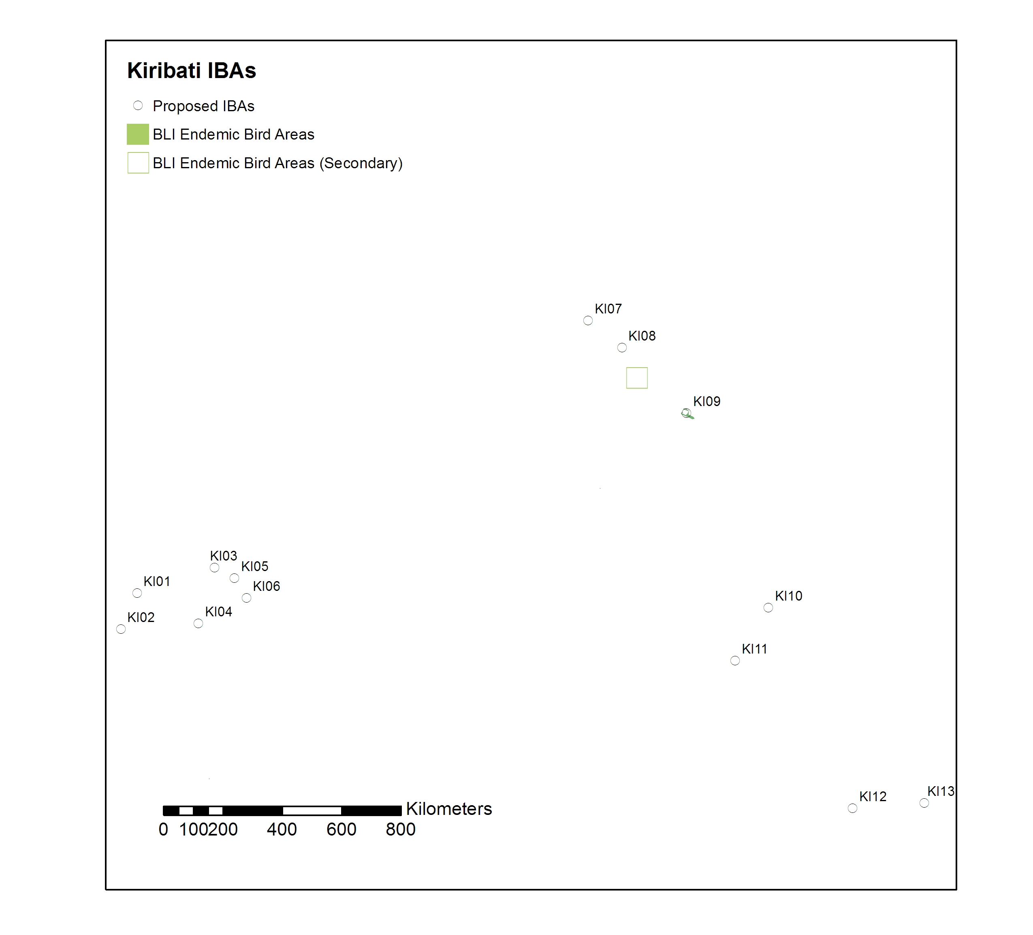

Summary Table for Kiribati.
(All sites are currently only proposed for Kiribati)
Site Name | Site Code | Site Area (ha) | Criteria | Priority Species | Key Threats | Protection Status
McKean Island | KI001 | 57 | A1, A4ii | Seabirds | Invasives | Part of PIPA
Nikumaroro (Gardner Island) | KI002 | 810 | A4ii | Seabirds | Invasives | Part of PIPA
Abariranga (Canton) Island | KI003 | 5900 | A4i | Waterbirds | Invasives | Part of PIPA
Orona Atoll (Hull Island | KI004 | 3000 | A4i, A4ii, A4iii | Seabirds, Waterbirds | Invasives | Part of PIPA
Enderbury Island | KI005 | 5700 | A1, A4ii | Seabirds, Waterbirds | Invasives | Part of PIPA
Rawaki (Phoenix Island) | KI006 | 108 | A1, A4i, A4ii, A4iii | Seabirds, Waterbirds | Invasives (rabbits) | Part of PIPA
Teraina (Washington Island) | KI007 | 1420 | A1, A2, A4i | Waterbirds, Rimatara Lorikeet, Kiritimati Reed-warbler | Invasives
Tabuaeran (Fanning Island) | KI008 | 14400 | A1, A4ii | Seabirds, Rimatara Lorikeet | Invasives
Kiritimati (Christmas Island) | KI009 | 65000 | A1, A2, A4i, A4ii, A4iii | Seabirds, Waterbirds, Kiritimati Reed-warbler | Invasives, Harvesting | Some areas set aside as Key Wildlife Areas
Malden Island | KI010 | 7970 | A4ii, A4iii | Seabirds, Waterbirds | Invasives (cats) | Restricted Access Wildlife Sanctuary
Starbuck Island | KI011 | 2500 | A4i, A4iii | Waterbirds | Invasives | Restricted Access Nature Reserve
Vostok Island | KI012 | 25 | A4ii | Seabirds | Invasives | Restricted Access Wildlife Sanctuary
Millenium (Caroline) Island | KI013 | 630 | A1, A4i, A4ii, A4iii | Seabirds, Waterbirds | Invasives

Marine IBAs around Kiribati
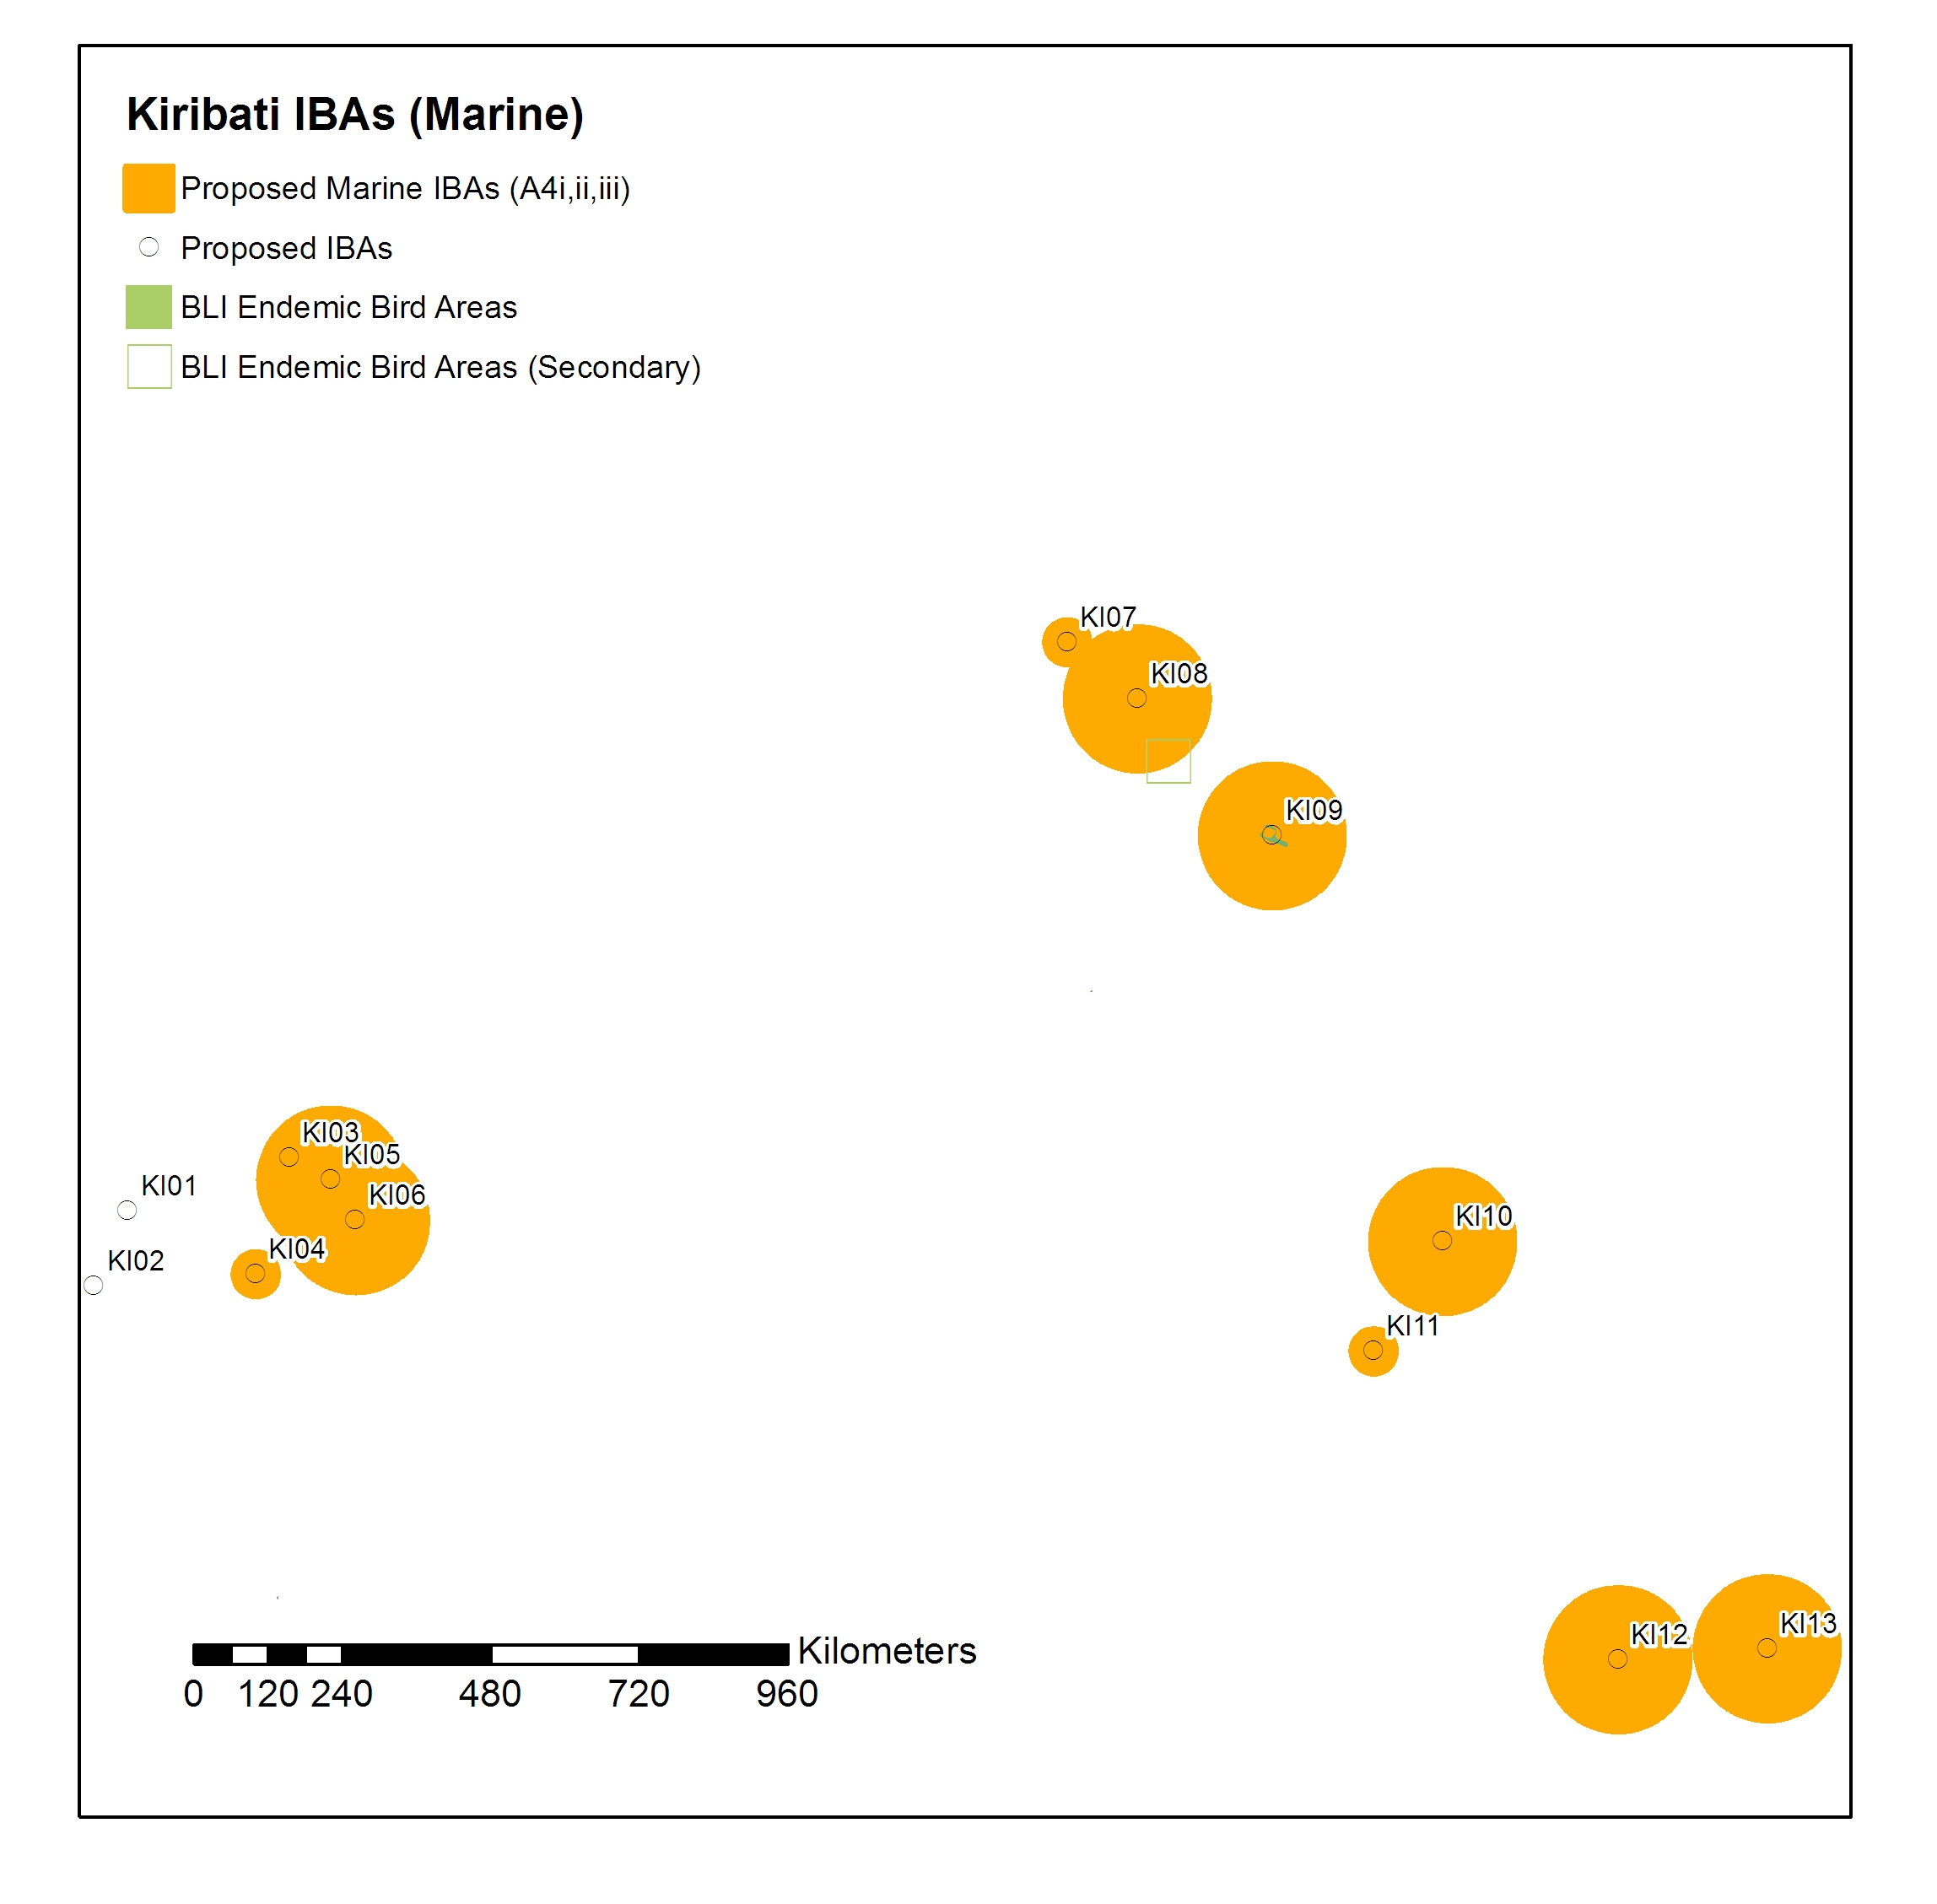
Next steps for developing a site-based conservation programme in Kiribati.
- Survey poorly-known sites and identify additional IBAs as necessary. The decision not to include sites in the Gilbert Islands needs to be agreed. Additionally some of the data used to identify sites is >30 years old, it would be worthwhile obtaining some more up-to-date estimates from these sites. Thirdly, assessing whether making the whole island of Kiritimati is the best way forward, or whether the island should be split into a number of smaller sites targeted at individual priority species.
- Identify habitat management opportunities/requirements. A considerable amount of effort has already been put into identifying priorities and opportunities for invasive eradication from some of the isolated seabird islands. Continuing to identify and deliver practical management opportunities should be a priority within Kiribati.
- Monitor IBAs to understand changes and provide feedback to conservation and policy mechanisms.
Prioritising IBAs for Action in Kiribati.
Rank | Site Name | Site Code | CR | EN | VU | NT | A4 | RR
1 | Kiritimati (Christmas Island) | KI009 |  | 2 | 1 |  | 13
2 | Teraina (Washington Island) | KI007 |  | 2 |  |  | 1
3 | Rawaki (Phoenix Island) | KI006 |  | 1 | 2 |  | 9
4 | Tabuaeran (Fanning Island) | KI008 |  | 1 |  |  | 1
5 | Millenium (Caroline) Island | KI013 |  |  | 1 |  | 7
6 | McKean Island | KI001 |  |  | 1 |  | 4
7 | Enderbury Island | KI005 |  |  | 1 |  | 3
8 | Malden Island | KI010 |  |  |  |  | 7
9 | Orona Atoll (Hull Island | KI004 |  |  |  |  | 3
10= | Starbuck Island | KI011 |  |  |  |  | 2
10= | Vostok Island | KI012 |  |  |  |  | 2
12= | Nikumaroro (Gardner Island) | KI002 |  |  |  |  | 1
12= | Abariranga (Canton) Island | KI003 |  |  |  |  | 1

This method of prioritisation is biased toward terrestrial species. A more appropriate mechanism may be to rank based on the number of A4 species on the site. This would identify Kiritimati, Rawaki and Millenium Island as the top three sites, based on the most recent seabird populations. This clearly does not consider the potential that sites may have for restoration – an assessment undertaken by Pierce et al (2007).
It should also be borne in mind that the Kiritimati site may be split into a number of smaller sites, each with its own suite of species.
Marine IBAs around Kiribati.

