Proposed
Important Bird Areas (IBAs)
in
Kiribati

Prepared by
Anuradha Gupta
University of Hawaii at Manoa
agupta@hawaii.edu

Prepared for
BirdLife International
Pacific Partnership
11 Ma’afu Street
GPO Box 18332
Suva, Fiji

August 2007
Contents

Executive Summary 3

Chapter 1. Introduction and Background to Kiribati 4
Kiribati’s Terrestrial Environment
Terrestrial Biodiversity

Chapter 2. Birds of Kiribati, including Status 6
Endemic Birds of Kiribati
Resident Land and Wetland Birds (Non-endemic)

Endangered Birds

Chapter 3. Important Bird Area Program 9

Using Birds as Indicators

International IBA Program

Criteria for selection of Important Bird Areas of global significance

Chapter 4. Identifying IBAs in Kiribati 11
CNMI Qualifying Bird Species under A1 and A2 criteria
Methods
Results – Data and Proposed IBAs
Phoenix Island Group
Line Island Group
Gilbert Island Group

Chapter 5. Conservation Coverage and IBAs in Kiribati 31
Conservation Activities in proposed IBAs
Conservation Issues and Threats to IBAs in Kiribati
IBAs and Other Biodiversity

Chapter 6. IBA Inventory 34

Chapter 7. References 47

Appendix 1. Thresholds for Seabird IBAs 49

Appendix 2. Key Stakeholders and Advocated Dissemination List 51

Appendix 3. Recommended Changes to the IUCN Redlist 52

Acknowledgements

Assistance and review were provided by:

Greg Stone, New England Aquarium
Raymond Pierce, Eco Oceania, Ltd.
Sue Taei, Conservation International
Executive Summary

The island nation of the Republic of Kiribati consists of 32 atolls and one raised limestone island, spread out in the mid Pacific and crossing the equator. Kiribati has one endemic bird species, the Line Islands Warbler. Other native species include breeding seabirds, and Kiribati has some of the world’s most significant seabird breeding colonies, with populations in the millions. Additionally, Kiribati has one introduced bird species that is endangered.

Important Bird Areas (IBA)s were identified in Kiribati through a desk-based literature review. IBAs were selected using BirdLife International criteria, including the presence of endangered and regionally-restricted species and populations of breeding seabirds meeting or exceeding regional or global thresholds.

Thirteen IBAs are proposed for Kiribati:

Phoenix Island Group
- Abariringa (Canton Island)
- Enderbury Island
- McKean Island
- Nikumaroro (Gardner Island)
- Orona (Hull Island)
- Rawaki (Phoenix Island)
Line Island Group
- Caroline Island (Millennium Island)
- Kiritimati (Christmas Island)
- Malden Island
- Starbuck Island
- Tabuaeran (Fanning Island)
- Teraina (Washington Island)
- Vostok Island

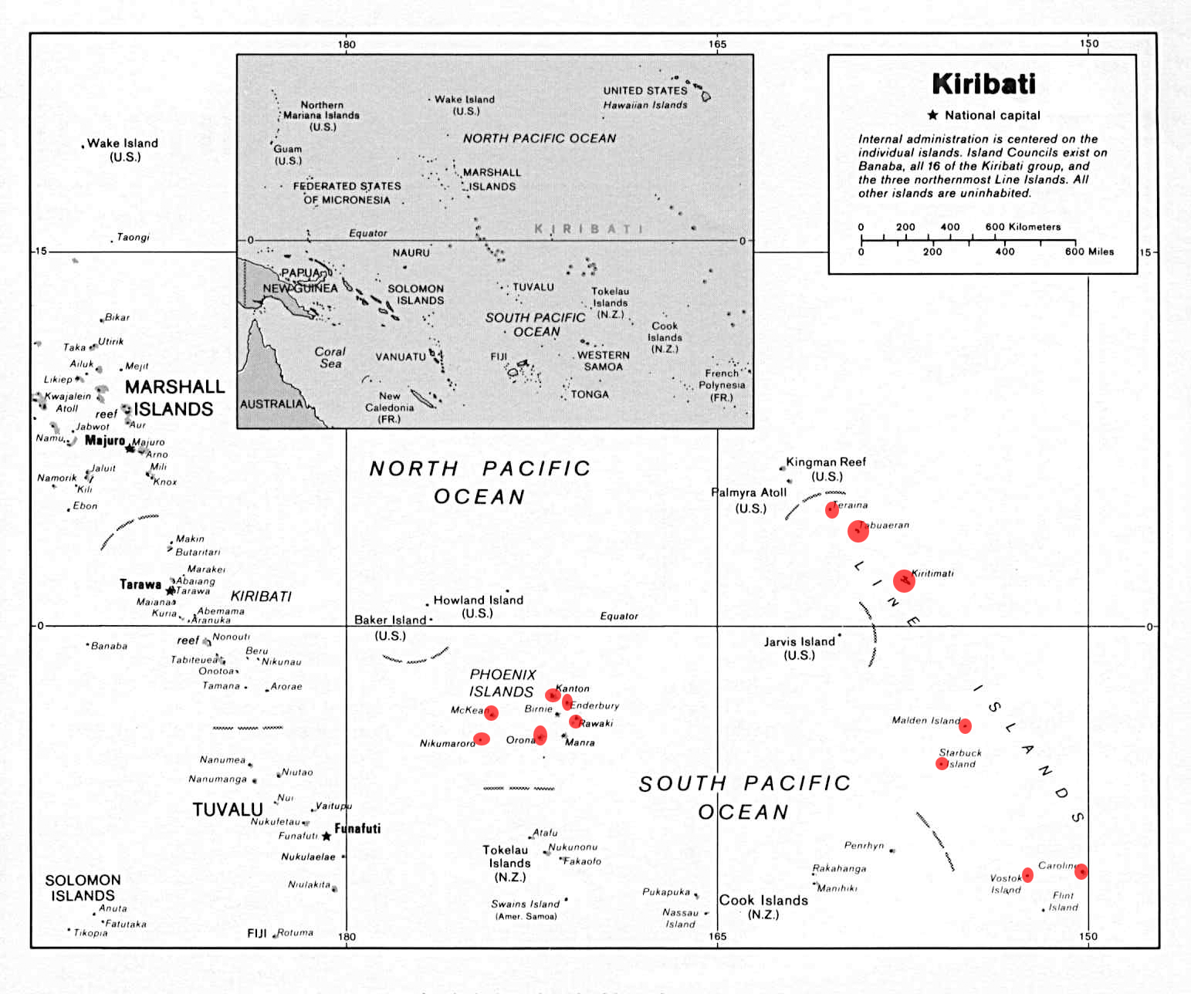
Proposed IBAs in Kiribati (in red)

Invasive species pose a major threat to the seabird populations, particularly mammals such as rats and cats. Declines in seabird populations have been attributed to interference with cats. Human settlements and associated activities may also pose additional threats, particularly to the endemic and endangered bird species. All of the atolls in the Phoenix Island complex are protected. Three of the atolls and parts of another one in the Line Islands complex are protected.

This report suggests a review of the IUCN Red List status of the Line Islands Warbler (Acrocephalus æquinoctialis), currently listed as Least Concern (LC). This report recommends a possible change to Near Threatened status.
Chapter 1. Introduction and Background to the Republic of Kiribati

Kiribati’s Terrestrial Environment

Geography
The island nation of the Republic of Kiribati consists of 32 atolls and one raised limestone island, spread out in the mid Pacific (Tebano, 1999). Islands are grouped into three island groups, the Gilbert Islands (17), Line Islands (8) and Phoenix Islands (8). Kiribati is located on both sides of the equator, between 04⁰43’ North to 11⁰25’ South latitude and 169⁰32’ East to 150⁰14’ West longitude (Thomas, 2002). The islands stretch nearly 4000 km from east to west and 2000 km from north to south across the equator (Teeb’aki, 1993). Kiribati has a total land area of 822.8 km² and an Exclusive Economic Zone of 3.5 million km² (Tebano, 1999). Most atolls have an elevation of four to five meters, while Kiribati’s maximum elevation is 81 m on Banaba island (Thomas, 2002). 21 of the atolls and islands are inhabited, with the majority of the population living on islands in the Gilbert chain. Kiritimati, in the Line Islands, is the world’s largest atoll in terms of contiguous landmass (388 km²), accounting for nearly half of the Kiribati’s total land area (Thomas, 2002).

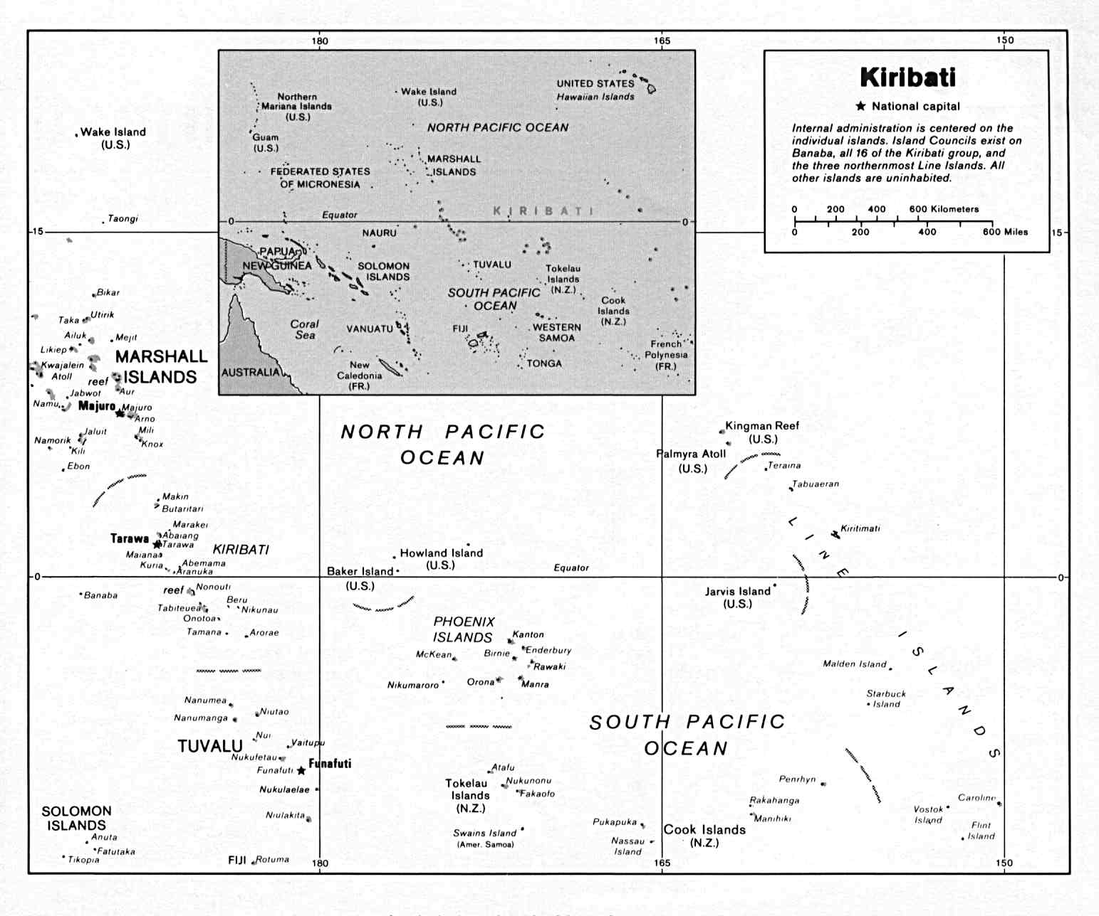
Figure 1. Atolls and islands in Kiribati (www.lib.utexas.edu)

Political Boundaries and Governance
Virtually all land in the Gilbert Islands is under private ownership in small hereditary holdings, whereas in the Line and Phoenix Islands, all land is owned by the government (Teeb’aki, 1993 ). Kiribati was a former British protectorate and colony (referred to as the Gilbert and Ellice Islands), and achieved independent in 1979. The capital is located on Tarawa. Inhabited islands are governed by local councils. During pre-colonial times there was a traditional system of tenure which rights and limitations (Lovell et al., 2000).

Kiribati is a signatory to several conventions with relevance to terrestrial resources, including the Convention of Biological Diversity, the Convention for the Protection of the Natural Resources and Environment of the South Pacific Region (SPREP convention), Convention for the Prohibition of Fishing with Long Driftnets in the South Pacific, and the UN Framework Convention on Climate Change (Tebano, 1999). Kiribati is also part of the World Heritage Convention (Lovell et al. 2000). Several national laws protect terrestrial resources including the Wildlife Conservation Ordinance of 1979 which protects endemic, sea, or regular migrant birds and established a number of reserves to protect seabird rookeries. It also prohibits the disturbing of breeding sites (Lovell et al., 2000). Kiribati has developed a National Environment Management Strategy which focuses on development controls (Lovell et al., 2000).

Geology
Banaba is a raised limestone island, while the 32 other islands are true atolls are overtop submerged volcanoes. There is some tricalcic phosphate rock (Tebano, 1999) but largely coral bedrock.

Climate
Most of the Gilbert Islands and several of the Line and Phoenix Islands are located in the dry belt of the equatorial oceanic climatic zone (Thomas, 2002). Islands near the equator typically experience two wet seasons each year, although rainfall varies annually and between islands. Precipitation ranges from 3,000 mm in the north to 1,110 mm in the south in the Gilbert group and from about 4,000 mm in the Line islands to less than 800 mm in parts of the Phoenix Group (Thomas, 2002). Droughts are common, hurricanes are rare, and the islands are strongly influenced by the El Nino Southern Oscillation events. Humidity is high but variable among the islands and daytime temperatures range between 31⁰ and 33⁰ year round (Thomas, 2002). Predominant winds are east to southeast tradewinds which blow for most of the year; a stormy season from November to February is characterized by westerlies (Teeb’aki, 1993).

Freshwater Resources
There are no surface streams, although many islands have a thin lens of slightly brackish water that is accessed by digging wells. Cisterns and catchment systems are used in some locations (Thomas, 2002). Teraina has a large freshwater lake. Water scarcity is a periodic event (Tebano, 1999).

Soils
Soils are considered some of the poorest in the world (Tebano, 1999). Soils are highly alkaline and coarse-textured, derived from coral and covered with thin layers of organic matter that can easily be removed. Soils are shallow and well-drained. There are some scattered phosphate soils that originated from guano deposits (Thomas, 1999). Phosphate has been extensively mined on Banaba island.

Land Cover
Terrestrial plant communities on the Gilbert Islands have largely been replaced by urban areas, villages, coconut plantations, shrub-dominant vegetation, or agriculture (including taro and gardens). The Line and Phoenix islands still feature coastal strand, coastal marsh, mangrove, and inland forest vegetation (Tebano, 1999). Banaba has some pinnacle vegetation on its limestone escarpment (Tebano, 1999).

Population, Economy, and Development
The population in 2000 was close to 84,500, unevenly distributed (Thomas, 2002). 93% of the population lives in the Gilbert Islands, with more than a third of that population concentrated on the South Tarawa, the capital of Kiribati. This area has one of the highest population densities in the world. Kiritimati holds about 4% of the population (just over 3000 people). In addition to Kiritimati, Tabuaeran and Teraina in the Line Islands are inhabited. Only Canton in the Phoenix group is inhabited. The Phoenix and Line Islands were uninhabited when discovered by western explorers. Much of Kiribati’s economy is subsistence-based, although many on Tarawa are now surviving on a cash-oriented basis. Copra and seaweed are the main exports, and tuna, handicrafts, fishing licenses, ecotourism, and sportsfishing contribute to the Gross Domestic Product (Tebano, 1999). The rate of population growth is 2.5%. In 1993 the Kiribati government was intending to pursue rapid development on Kiritimati (Watling, 1995).

Terrestrial Biodiversity

There is only one endemic vertebrate species, the Line Islands Reeds Warbler (Christmas Island Warbler, Kokikokiko; Acrocephalus aequinoctialis). Kiribati’s CBD report and MELAD (2006) state that the indigenous vegetation and flora of Kiribati is among the poorest on earth, and in the Gilbert Islands and some locations in other inhabited islands, has been severely modified or removed.

Kiribati’s CBD report (Tebano, 1999) states that the terrestrial vegetation associations of Kiribati are limited to:
- Coastal strand vegetation
- Mangroves and coastal marsh vegetation (limited)
- Inland forest
- Limestone escarpment containing pinnacle vegetation

Secondary and cultural vegetation associations include:
- Coconut palm dominated agricultural lands
- Giant swamp taro
- Ruderal vegetation
- Shrub dominant vegetation
- Secondary disclimax vegetation on Banaba.

Table 1 gives known species information for both marine and terrestrial systems.

Table 1. Overview of the Terrestrial Biodiversity of Kiribati (Tebano, 1999; MELAD, 2006)
Species | Known Species | Known native | Known endemic | Known threatened
Plants | ~200 |  |  | >50
Invertebrates | 92 |  |  | 4 (marine)
Reptiles | 6 (sea turtles) |  |  | 3
Birds |  |  | 1
Mammals | Introduced terrestrial mammals  6 marine | 0% of terrestrial mammals
Bryophytes | 3 |  |  | 0
Pteridophytes | 2 |  |  | 0

Kiribati is known for its rich marine ecosystems.

Chapter 2. Birds of Kiribati, including Status

There are 79 recorded bird species for Kiribati (MELAD, 2006; Lepage, 2007; Child, 1960). Of these, 23 are regular resident species. There are additional conflicting reports of resident species that have been introduced in modern times, including the Micronesian Pigeon, Pacific Pigeon, and Friendly Ground Dove. Child (1960) believed these birds, seen in inhabited islands in the Gilbert Islands, to be introduced from other parts of the Pacific. They were not included in the analysis of IBAs.

Kiribati has one endemic bird, the Line Islands (Christmas Island) Warbler (Bokikokiko). The Kuhl’s Lorikeet is suspected to have been introduced by early Polynesian residents. Due to the endangered status of the Kuhl’s Lorikeet and the active management of the species in Kiritimati, this bird was included in IBA analysis.

Two birds have been recorded in the past, but are believed to have been extirpated from Kiribati. Records are conflicting, as they may have been originally vagrants and thus no longer recorded from the islands.

Tables 2-4 provide lists of known recorded birds in Kiribati (MELAD, 2006; Lepage, 2007; Child, 1960).
Codes used are:
R Resident Breeder
M Regular Migrant
M/V Migrant or Vagrant
V Vagrant
I Introduced
Ext Extirpated

IUCN status codes are:
EN Endangered
VU Vulnerable
NT Near Threatened

Table 2. Resident Land Birds, Native and Introduced

Family | Common Name | Species Name | Kiribati Name | Code | IUCN  Status
Parrots, Cockatoos (Psittacidae) | Kuhl’s (Scarlet-breasted, Rimatara) Lorikeet | Vini kuhlii | Kura | I, R | EN
Old World Warblers (Sylviidae) | Line Islands (Christmas Island) Warbler | Acrocephalus æquinoctialis | Bokikokiko | R
Doves, Pigeons (Columbidae) | Micronesian Imperial-Pigeon | Ducula oceanica |  | I | NT
Doves, Pigeons (Columbidae) | Friendly Ground-Dove | Gallicolumba stairii |  | I
Doves, Pigeons (Columbidae) | Pacific Imperial Pigeon | Ducula pacifica | Rube | I

Table 3. Breeding Seabirds

Family | Common Name | Species Name | Kiribati Name | Code | IUCN  Status
Boobies (Sulidae) | Brown Booby | Sula leucogaster | Kibui, Tairoiro | R
Boobies (Sulidae) | Masked Booby | Sula dactylatra | Moukena | R
Boobies (Sulidae) | Red-footed Booby | Sula sula | Koota | R
Frigatebirds (Fregatidae) | Great Frigatebird | Fregata minor | Marenaiti, Bairakau, Ubamara | R
Frigatebirds (Fregatidae) | Lesser Frigatebird | Fregata ariel | Uubaitoi or Ubamei | R
Gulls, Terns (Laridae) | Black Noddy | Anous minutus | Mangkiri, Kunei | R
Gulls, Terns (Laridae) | Blue-grey Noddy | Procelsterna cerulean | Raurau | R
Gulls, Terns (Laridae) | Brown Noddy | Anous stolidus | Io | R
Gulls, Terns (Laridae) | Great Crested tern | Sterna bergii | Karakara | R
Gulls, Terns (Laridae) | Grey-backed Tern | Sterna lunata | Tarangongo, Maningongo | R
Gulls, Terns (Laridae) | Sooty tern | Sterna fuscata | Keeu, Tarariki, Te Keeu | R
Gulls, Terns (Laridae) | White tern | Gygis alba | Matawa, matawanaba | R
Herons, Egrets, Bitterns (Ardeidae) | Pacific Reef Heron | Egretta sacra | Kaai | R
Petrels, Shearwaters (Procellariidae) | Audubon’s shearwater | Puffinus iherminieri | Nna | R
Petrels, Shearwaters (Procellariidae) | Bulwer's Petrel | Bulweria bulwerii |  | R
Petrels, Shearwaters (Procellariidae) | Christmas Shearwater | Puffinus nativitatis | Tinebu | R
Petrels, Shearwaters (Procellariidae) | Phoenix Petrel | Pterodroma alba | Ruru. | R | EN
Petrels, Shearwaters (Procellariidae) | Wedge-tailed shearwater | Puffinus pacificus | Tangiuoua | R
Storm-Petrels (Hydrobatidae) | Polynesian (White-throated) storm-petrel | Nesofregatta fuliginosa | Bewebwe ni marawa | R | VU
Tropicbirds (Phaethontidae) | Red-tailed Tropicbird | Phæthon rubricauda | Taake | R
Tropicbirds (Phaethontidae) | White-tailed Tropicbird | Phaeton lapturus | Korouangutungutu. | R

Table 4. Migrant and Vagrant Bird Species Records
Family | Common Name | Species Name | Kiribati Name | Code | IUCN Status
Boobies (Sulidae) | Masked Gannet | Sula cyanops | Kibui | M
Gulls, Terns (Laridae) | Black-naped Tern | Sterna sumatrana | Kiakia | M
Hawks (Accipitridae) | Mottled Hawk | Astur rufitorques | Kibui | M
Plovers (Charadriidae) | Pacific Golden Plover | Pluvialis fulva | Kun | M
Sandpipers, Snipe (Scolopacidae) | Bristle- thighed curlew | Numenius tahitiensis | Kewe | M | VU
Sandpipers, Snipe (Scolopacidae) | Ruddy Turnstone | Arenaria interpres | Kitibwa | M
Sandpipers, Snipe (Scolopacidae) | Sanderling | Calidris alba | Kewe-wii anau | M
Sandpipers, Snipe (Scolopacidae) | Sandpiper | Calidris arenaria | Kitiba | M
Sandpipers, Snipe (Scolopacidae) | Sandsnipe | Totanus icanus | Kun | M
Sandpipers, Snipe (Scolopacidae) | Wandering tattler | Heteroscelus incanus | Kiriri | M
Cuckoos (Cuculidae) | Long-tailed Koel | Eudynamys taitensis |  | M/V
Ducks, Geese, Swans (Anatidae) | Eurasian Teal | Anas crecca |  | M/V
Ducks, Geese, Swans (Anatidae) | Eurasian Wigeon | Anas penelope |  | M/V
Ducks, Geese, Swans (Anatidae) | Mallard | Anas platyrhynchos |  | M/V
Ducks, Geese, Swans (Anatidae) | Northern Pintail | Anas acuta |  | M/V
Ducks, Geese, Swans (Anatidae) | Northern Shoveler | Anas clypeata |  | M/V
Gulls, Terns (Laridae) | Laughing Gull | Larus atricilla |  | M/V
Gulls, Terns (Laridae) | Little Tern | Sternula albifrons |  | M/V
Gulls, Terns (Laridae) | Little White-tern | Gygis microrhyncha |  | M/V
Gulls, Terns (Laridae) | Long-tailed Jaeger | Stercorarius longicaudus |  | M/V
Gulls, Terns (Laridae) | Pomarine Jaeger | Stercorarius pomarinus |  | M/V
Gulls, Terns (Laridae) | Ring-billed Gull | Larus delawarensis |  | M/V
Gulls, Terns (Laridae) | South Polar Skua | Stercorarius maccormicki |  | M/V
Petrels, Shearwaters (Procellariidae) | Black-winged Petrel | Pterodroma nigripennis |  | M/V
Petrels, Shearwaters (Procellariidae) | Bonin Petrel | Pterodroma hypoleuca |  | M/V
Petrels, Shearwaters (Procellariidae) | Cook's Petrel | Pterodroma cookii |  | M/V | EN
Petrels, Shearwaters (Procellariidae) | Gould's Petrel | Pterodroma leucoptera |  | M/V
Petrels, Shearwaters (Procellariidae) | Hawaiian Petrel | Pterodroma sandwichensis |  | M/V | VU
Petrels, Shearwaters (Procellariidae) | Juan Fernandez Petrel | Pterodroma externa |  | M/V | VU
Petrels, Shearwaters (Procellariidae) | Mottled Petrel | Pterodroma inexpectata |  | M/V | NT
Petrels, Shearwaters (Procellariidae) | Pink-footed Shearwater | Puffinus creatopus |  | M/V | VU
Petrels, Shearwaters (Procellariidae) | Short-tailed Shearwater | Puffinus tenuirostris |  | M/V
Petrels, Shearwaters (Procellariidae) | Sooty Shearwater | Puffinus griseus |  | M/V | NT
Petrels, Shearwaters (Procellariidae) | Stejneger's Petrel | Pterodroma longirostris |  | M/V | VU
Petrels, Shearwaters (Procellariidae) | White-necked Petrel | Pterodroma cervicalis |  | M/V
Plovers (Charadriidae) | Black-bellied Plover | Pluvialis squatarola |  | M/V
Sandpipers, Snipe (Scolopacidae) | Bar-tailed Godwit | Limosa lapponica |  | M/V
Sandpipers, Snipe (Scolopacidae) | Black-tailed Godwit | Limosa limosa |  | M/V | NT
Sandpipers, Snipe (Scolopacidae) | Common Sandpiper | Actitis hypoleucos |  | M/V
Sandpipers, Snipe (Scolopacidae) | Gray-tailed Tattler | Tringa brevipes |  | M/V
Sandpipers, Snipe (Scolopacidae) | Pectoral Sandpiper | Calidris melanotos |  | M/V
Sandpipers, Snipe (Scolopacidae) | Red Phalarope | Phalaropus fulicarius |  | M/V
Sandpipers, Snipe (Scolopacidae) | Sharp-tailed Sandpiper | Calidris acuminata |  | M/V
Sandpipers, Snipe (Scolopacidae) | Whimbrel | Numenius phaeopus |  | M/V
Storm-Petrels (Hydrobatidae) | Band-rumped Storm-Petrel | Oceanodroma castro |  | M/V
Storm-Petrels (Hydrobatidae) | Leach's Storm-Petrel | Oceanodroma leucorhoa |  | M/V
Storm-Petrels (Hydrobatidae) | White-faced Storm-Petrel | Pelagodroma marina |  | M/V
Storm-Petrels (Hydrobatidae) | Wilson's Storm-Petrel | Oceanites oceanicus |  | M/V
Gulls, Terns (Laridae) | Franklin's Gull | Larus pipixcan |  | V
Petrels, Shearwaters (Procellariidae) | Tahiti Petrel | Pterodroma rostrata |  | V
Ducks, Geese, Swans (Anatidae) | Canada Goose | Branta canadensis |  | V

Endangered Species

Kiribati has three regularly breeding resident species listed on the IUCN Red List. One regular migrant is also listed, as well as several migrants or vagrants.

IUCN Red List
The International Union for the Conservation of Nature (IUCN) Red List of Globally Threatened Birds lists birds according to 6 categories: Critically Endangered, Endangered, Vulnerable, Near Threatened, Least Concern, and Data Deficient. Three regularly-breeding resident species are found in Kiribati:

Kuhl’s (Scarlet-breasted, Rimatara) Lorikeet Vini kuhlii Endangered (EN)
Phoenix Petrel Pterodroma alba Endangered (EN)
Polynesian (White-throated) storm-petrel Nesofregatta fuliginosa Vulnerable (VU)

The Micronesian Imperial Pigeon (Ducula oceanica) is also listed as Near Threatened (NT). However, there are few records for the species, and it may have been introduced or kept in captivity.

Additional IUCN-listed birds visit Kiribati as migrants or vagrants, including:

Cook's Petrel Pterodroma cookii Endangered (EN)
Hawaiian Petrel Pterodroma sandwichensis Vulnerable (VU)
Juan Fernandez Petrel Pterodroma externa Vulnerable (VU)
Pink-footed Shearwater Puffinus creatopus Vulnerable (VU)
Stejneger's Petrel Pterodroma longirostris Vulnerable (VU)
Bristle- thighed curlew Numenius tahitiensis Vulnerable (VU)
Black-tailed Godwit Limosa limosa Near Threatened (NT)
Mottled Petrel Pterodroma inexpectata Near Threatened (NT)
Sooty Shearwater Puffinus griseus Near Threatened (NT)

Of the listed migrant species, only the Bristle-thighed Curlew is a regular migrant. The endangered (EN) Tuamoto Sandpiper has one record from Kiribati, which may indicate that it was either a migrant that has been extirpated, or that it was a vagrant.

Chapter 3. Important Bird Area Program

Using Birds as Indicators

Important Bird Areas (IBAs) are sites of global, regional, or sub-regional biodiversity conservation importance that are chosen using internationally agreed, objective, quantitative, and scientifically defensible criteria (Bennun & Njoroge, 1999). The IBA process uses birds to select key sites for conservation. IBAs are selected because they may hold threatened or endangered birds, birds restricted to particular regions or biomes, or significantly large populations of congregatory waterbirds. Through this process, sites directly important for bird conservation are identified and prioritized for conservation actions. In addition, birds have been shown to be extremely good indicators of overall biodiversity, and throughout the world, IBAs themselves protect a high percentage of many nations’ total biodiversity (Stattersfield et al, 1998; Bennun & Njoroge, 1999).

Birds serve as a good indicator for several reasons. In certain places birds are some of the largest terrestrial predators, and thus are sensitive to changes throughout their ecosystems. Multiplying effects from less visible biodiversity in lower trophic levels may be manifested and then observed in birds. Birds also play a role in maintaining biodiversity through their ecological role as pollinators and seed dispersers, and thus a change in bird biodiversity may indicate a change in overall biodiversity. Birds also tend to be well studied and well understood, and because they are larger, aesthetically pleasing fauna, they lend themselves easily to many community-based research and monitoring programs. Thus birds, for the inherent biodiversity and ecosystem service value they hold and the popular appeal they hold to people, serve as good indicator species for overall biodiversity and ecosystem health. In addition, conserving a site because it holds bird species of concern will most probably lead to conservation of other important plant and animal species as well.

International IBA Program

The IBA Program has been developed by BirdLife International and tested throughout the world. IBAs have been identified in Europe, Africa, and in parts of Asia, North America, South America, and Australia.

The International IBA Program is designed to identify areas of global significance. However, national programs have used the same process to identify sites important globally, nationally, or regionally. To be listed as an IBA of global importance, sites must meet one of four criteria. These criteria are listed in Table 5. For some of the criteria’s categories, quantitative thresholds are set to aid site selection and to help define the concept of “significant numbers” of species (Appendix A1 lists thresholds for Pacific sea and shorebirds).

Table 5. Criteria for selection of Important Bird Areas of global significance (Bennun & Njoroge, 1999)
Category | Criterion | Notes
A1. Globally-threatened Species | The site regularly holds significant numbers of a globally threatened species, or other species of global conservation concern. | Globally threatened species are those listed on the IUCN Red List. Sites qualify if they are known or thought to hold a population of Critically Endangered or Endangered species. Population-size thresholds are set for species classified as Vulnerable, Conservation Dependent, Data Deficient, and Near Threatened. Thresholds may be set (1% of global population, >10 pairs or 30 individuals).
A2. Restricted Range species | The site is known or thought to hold a significant component of the restricted-range species whose breeding distributions define an Endemic Bird Area (EBA) or Secondary Area (SA) | Restricted-range species are defined as all landbirds which have had, throughout historical times, a total global breeding range estimated at below 50,000 km². EBAs are defined as an area which encompasses the overlapping breeding ranges of restricted-range bird species, such that the complete ranges of two or more restricted-range species are entirely included within the boundary of the EBA. EBAs capture endemic birds and other birds with limited ranges.
A3. Biome-restricted species | The site is known or thought to hold a significant component of the group of species whose distributions are largely or wholly confined in one biome. | This applies to species that share a distribution of greater than 50,000 km² and occur within a biome, defined as a major regional ecological community characterized by distinctive life forms and principal plant species.
A4. Congregations | (i) The site is known or thought to hold, on a regular basis, >1% of a biogeographic population of a congregatory waterbird species. | Follows Rose & Scott (1994). Thresholds may be set regionally or inter-regionally. See Appendix A1.
 | (ii) The site is known or thought to hold, on a regular basis, >1% of the global population of a congregatory seabird or terrestrial species. | Thresholds may be set regionally or inter-regionally. See Appendix A1.
 | (iii) The site is known or thought to hold, on a regular basis, >20,000 waterbirds or >10,000 pairs of seabirds of one or more species. | Follows the Ramsar criterion for waterbirds. Use of this criterion is discouraged when data is good enough to permit the use of A4 (i) or (ii).
 | (iv) The site is known or thought to exceed thresholds set for migratory species at bottleneck sites. | Thresholds may be set regionally or inter-regionally.

In addition to the criteria, site selection requires the following:
- IBAs must have a definitive border, such that the IBA is different in habitat or character from surrounding areas;
- IBAs should exist as a protected area or be managed for conservation;
- IBAs should, either alone or with other sites, be a self-sufficient area that provides the requirements of the birds that use it during the time they are present; and
- Selection of a set of IBAs in an Endemic Bird Area should also be designed to ensure that all restricted-range species are present in significant numbers in one or more sites (Bennun & Njoroge, 1999).

Chapter 4. Identifying IBAs in Kiribati

IBAs in Kiribati must qualify for the presence of threatened species (A1), restricted species (A2) or aggregations of breeding seabirds meeting or exceeding the regional thresholds. The requirements for IBA selection in Kiribati are summarized in Table 6.

Table 6. KIRIBATI Qualifying Bird Species under A1 and A2 criteria
Criteria category | Species meeting global criteria (BirdLife (2003a&b); IUCN REDLIST)
A1. Globally-threatened Species | * Must meet threshold populations (>10 pairs or 30 individuals)
  Kuhl’s (Scarlet-breasted) Lorikeet | Vini kuhlii
  Phoenix Petrel | Pterodroma alba
  Polynesian (White-throated) storm-petrel* | Nesofregatta fuliginosa*
A2. Restricted Range species
  Line Islands (Christmas Island) Warbler^{E} | Acrocephalus æquinoctialis
  E Endemic to Kiribati
A3. Biome-restricted species | Criteria not applicable in the FSM
A4. Congregations | 20,000 total birds or  Regional Thresholds (Appendix 1)

Methods

A literature review was conducted as part of this report. Findings from the literature review are summarized in the following section, and are summarized in Table 7. The literature review focused only on those species listed in Table 6 or on aggregations of seabirds, and did not consider the presence of threatened or endangered migrant and vagrant birds in its analysis of proposed IBAs.

Results

Results – Summary
Table 7 provides a summary of the results of a literature review. This table compiles information from the literature review and presents the range of bird populations observed at various atolls, taken from various sources which surveyed the islands in various years. IBA selection was based on the presence of threshold populations. Given that various observations were made at various times of the year, possibly missing the nesting season, the maximum end of the range of actual observed birds was generally used in comparison with the threshold.
Table 7. Results of Literature Review, Summary

Island | Kuhl's Lorikeet | Christmas Island Warbler | Audubon's shearwater | Christmas Shearwater | Wedge-tailed Shearwater | Phoenix Petrel | White-throated storm Petrel | Red-tailed Tropicbird | White-tailed Tropicbird | Masked Booby | Brown Booby | Red-footed Booby | Great Frigatebird | Lesser Frigatebird | Sooty Tern | Grey-backed Tern | Brown Noddy | Black Noddy | Blue Noddy | White Tern | Crested Terns | TOTAL POPULATION
GILBERT ISLANDS | Only small seabird populations; No population data available.
PHOENIX ISLANDS
Abariringa (Canton Island) |  |  |  | x | x | x |  |  |  | 100 | 50 | 200 | 1 | 10-100 | 100 | 4000-5000 | 800-5000 | 100 | 5 | 40 |  | 5000-10000
Birnie Island |  |  |  |  |  | x | x | 8-10 |  | 220-500 | 20-50 | 6 |  | 20 | 5000 | 600 | 800-4000 | 1 | 2 | 30-54 |  | 4800-7000
Enderbury Island |  |  | 100 | 4 | 94 | 1 |  | 200-1000 |  | 800-2000 | 50-200 | 200-800 | 500-600 | 7000-15000 | 6000-800000 | 1000-10000 | 100-2000 | 200 | 7 | 50-100 |  | 20500-810,000
Manra (Sydney Island) |  |  |  |  |  |  |  | 20 |  | 200 |  | 100 | 50 | 200 | 4000-8000 | 10-1200 | 50 | 10-1000 | 1 | 200 |  | 4000-11000
McKean Island |  |  | 120 |  | 2 |  | 20-1000 | 68 |  | 600-800 | 150 | 120 | 800 | 3000-85000 | 500 | 800 | 3260 | 12 | 1 | 200 |  | 10000-86000
Nikumaroro (Gardner Island) |  |  |  |  |  |  |  | 50-200 | 10 | 8-10 | 15000 | 200 | 2-10 | 120-1000 | 9-10 |  | 40-50 | 1000 |  | 50-400 |  | 2100-16000
Orona (Hull Island) |  |  |  |  |  |  |  | 100 |  | 2 |  | 1000 | 100 | 1200 | 500-3000000 | 0-3000 | 20-50 | 4000 |  | 30-600 |  | 1.2 to 3 million
Rawaki (Phoenix Island) |  |  | 1600 | 1000 | 500 | 22-1000 petrels | 40 | 50-140 |  | 1400-3000 | 50-500 | 6-100 | 10-1000 | 8600-50000 | 20000 | 2000-150000 | 8000 | 20-80000 | 100-10000 | 40 |  | 50000-275,000
LINE ISLANDS
Caroline Island |  |  |  |  |  |  |  | 300 |  | 10-400 | 15-40 | 5000-7000 | 5471-10000 | 200-1000 | 500000-1100000 |  | 1000-3000 | 7000-17000 | 5-10 | 4000-8000 |  | 530,000-950,000
Flint Island | Small Seabird Populations
Kiritimati (Christmas Island) |  | 400 | 500 | 2000-15000 | 100000-500000 | 25000 (1980) | 350 | 8000 |  | 1000 | 300 | 8500 | 10000 | 1000-5000 | 15000000-25000000 | 1500 | 4000 | 14500 | 2700 | 5000 | 700 | 15 to 25 million
Malden Island |  |  |  |  |  |  |  | 40 |  | 1000-3000 | 2000 | 5000 | 3000 | 7000 | 10000 | 2500 | 500 |  | 200 | 50 |  | 7000-33,290
Starbuck Island |  |  |  |  |  |  |  | 10 |  |  |  |  |  | 15 | 2500000-3000000 |  |  |  |  |  |  | 2.5 to 3 million
Tabuaeran (Fanning Island) | 50 |  |  |  |  |  |  |  | 50 |  |  | 3000 | 1000 |  |  |  | 2000 | 2000 |  | 2000 |  | 10,000
Teraina (Washington Island) | 1000-1600 | 2000 |  |  |  | X | x |  | 100 | rare |  | 2000 |  |  |  |  |  |  |  | 2000 |  | 5000
Vostok Island |  |  |  |  |  |  |  |  |  | 200-500 | 25-30 | 3000 | 4500 | 500 | 40-50 |  | 500 | 3000 | 1250 | 1000 |  | 13000

Results - Literature Review

Gilbert Islands Group
There is no population data for breeding seabirds publicly available for the Gilbert islands. Amerson (1969) did make it into the Gilbert Islands during his expedition, but gave no population data for the two islands he visited. He wrote that on Little Makin no birds were recorded, and that on Makin, seabirds were observed, but that there was no evidence of breeding. Dahl (1986) reviewed the Gilbert Island chain, assessing each island for its terrestrial conservation value. Nearly all of the atolls and Banaba island were assessed a low terrestrial conservation index score. Four exceptions were the islands of Abaiang, Butaritari, Nonouti, and Tabiteuea. He wrote that these four islands had seabird rookeries, but gave no population data. He did write that Butaritari held “small” seabird rookeries on the islets of Kotabu and Nabini. He also wrote that the “small” forested islet on Numatong islet in Nonouti might be considered as a reserve under local management. The rookery on Abaiang was located on Teirio islet and that on Tabiteuea was located on Namauri islet.

Phoenix Island Group

Abariringa (Canton Island)
Child (1960) also noted the Dusky Shearwater as occurring here (as well as in McKean and Kiritimati). King (1972) wrote that the Red-footed Booby and Great Frigatebird had been extirpated from Canton.

Source | Audubon's shearwater | Christmas Shearwater | Wedge-tailed Shearwater | Phoenix Petrel | Bulwer's Petrel | White-throated storm Petrel | Red-tailed Tropicbird | White-tailed Tropicbird | Masked Booby | Brown Booby | Red-footed Booby | Great Frigatebird | Lesser Frigatebird | Sooty Tern | Grey-backed Tern | Brown Noddy | Black Noddy | Blue Noddy | White Tern
Child (1960) |  | x | x | x
Sibley and Clapp (1967) |  |  |  |  |  |  |  |  |  |  |  |  | 10-15
Obura and Stone (2002) |  |  |  |  |  |  |  |  | 100 | 50 |  |  | 50 |  | 5000 | 5000
Pierce et al. (2006) PAIRS | 0 | 0 | 0 | 0 | 0 | 0 | 0 | 0 | 0 | 50i | 100 | 1i | 50 | 50 | 2000 | 800i | 50 | 5i | 20

2002 Total: 10,200
2006 Total: 5,396

IBA Qualifying species:
Bird Population Threshold Category
Phoenix Petrel Unknown A1
Grey-backed Tern 4000-5000 individuals 1000 pairs A4i
Birnie Island
King (1972) wrote that breeding seabird populations on Bernie were not large, but that the island as nearly undisturbed. Brooke et al. (2007) gave Birnie a high priority ranking for vertebrate eradication, noting that the Polynesian Storm Petrel and Phoenix Petrels both used the island. Rats are the main eradication target.

Source | Audubon's shearwater | Christmas Shearwater | Wedge-tailed Shearwater | Phoenix Petrel | Bulwer's Petrel | White-throated storm Petrel | Red-tailed Tropicbird | White-tailed Tropicbird | Masked Booby | Brown Booby | Red-footed Booby | Great Frigatebird | Lesser Frigatebird | Sooty Tern | Grey-backed Tern | Brown Noddy | Black Noddy | Blue Noddy | White Tern
Nelson (1978) |  |  |  |  |  |  |  |  | 350-400
Obura and Stone (2002) |  |  |  |  |  |  | 10 |  | 500 | 50 |  |  |  | 5000 | 600 | 800 |  |  | 30
Pierce et al. (2006) PAIRS | 0 | 0 | 0 | 0 | 0 | 0 | 4 | 0 | 109 | 9 | 3 | 0 | 20i | P | 300 | 2000 | 1i | 2i | 27i
Brooke et al. (2007) |  |  |  | x |  | x

2002 Total: 6,990
2006 Total: 4,882

IBA Qualifying species:
None
Enderbury Island
King (1972) wrote that cats were observed causing high mortality in Sooty Terns. Obura and Stone (2002) noted the presence of rats and feral cats, and observed virtually no petrels, shearwaters, reef herons, or Blue-gray Noddies.

Source | Audubon's shearwater | Christmas Shearwater | Wedge-tailed Shearwater | Phoenix Petrel | Bulwer's Petrel | White-throated storm Petrel | Red-tailed Tropicbird | White-tailed Tropicbird | Masked Booby | Brown Booby | Red-footed Booby | Great Frigatebird | Lesser Frigatebird | Sooty Tern | Grey-backed Tern | Brown Noddy | Black Noddy | Blue Noddy | White Tern
Sibley and Clapp (1967) |  |  |  |  |  |  |  |  |  |  |  |  | 15,000 (10,000 breeding)
King (1972) |  |  |  |  |  |  |  |  |  |  |  |  |  | 800,000 | 10,000
Nelson (1978) |  |  |  |  |  |  |  |  | 800-850
Obura and Stone (2002) |  |  |  |  |  |  | 200 |  | 2000 | 50 | 800 | 500 | 7000 | 15000 | 5000 | 100 |  |  | 50
Pierce et al. (2006) PAIRS | 50 | 2 | 47 | 1i | 0 | 0 | 500 | 0 | 500 | 100 | 100 | 300 | 4000 | 3000 | 500 | 1000 | 100 | 7i | 50

1972 Total: 810,000
2002 Total: 30,700
2006 Total: 20,506

IBA Qualifying species:
Bird Population Threshold Category
Phoenix Petrel 1 A1
Red-tailed Tropicbird 200-1000 160 A4ii
Masked Booby 800-2000 1000 A4ii
Lesser Frigatebirds 7000-15000 1000 A4ii
Sooty Terns 6000-800,000 20,000 A4i
Grey-backed Terns 1000-10,000 2000 A4i
All >20,000 A4iii
Manra (Sydney Island)
King (1972) wrote that both the Polynesian and Black rats were present on Manra, as well as cats and dogs.

Source | Audubon's shearwater | Christmas Shearwater | Wedge-tailed Shearwater | Phoenix Petrel | Bulwer's Petrel | White-throated storm Petrel | Red-tailed Tropicbird | White-tailed Tropicbird | Masked Booby | Brown Booby | Red-footed Booby | Great Frigatebird | Lesser Frigatebird | Sooty Tern | Grey-backed Tern | Brown Noddy | Black Noddy | Blue Noddy | White Tern
King (1972) |  |  |  |  |  |  |  |  |  |  |  |  |  | 4000
Obura and Stone (2002) |  |  |  |  |  |  |  |  |  |  |  | 50 |  |  | 10 |  | 10
Pierce et al. (2006) PAIRS | 0 | 0 | 0 | 0 | 0 | 0 | 10 | 0 | 100 | 0 | 50 | 0 | 100 | 4000 | 600 | 50i | 500 | 1i | 100

1972 Total: 4000
2006 Total: 10,971

IBA Qualifying species:
None

McKean Island

Source | Audubon's shearwater | Christmas Shearwater | Wedge-tailed Shearwater | Phoenix Petrel | Bulwer's Petrel | White-throated storm Petrel | Red-tailed Tropicbird | White-tailed Tropicbird | Masked Booby | Brown Booby | Red-footed Booby | Great Frigatebird | Lesser Frigatebird | Sooty Tern | Grey-backed Tern | Brown Noddy | Black Noddy | Blue Noddy | White Tern
Child (1960) |  |  | x
King (1972) |  |  |  |  |  | 1000 |  |  |  |  |  |  | 85,000
Nelson (1978) |  |  |  |  |  |  |  |  | 600-700
Pierce et al. (2006) PAIRS | 60 | 0 | 2i | 0 | 0 | 10 | 34 | 0 | 400 | 75 | 60 | 400 | 1500 | 500i | 800i | 1630 | 6 | 1i | 100

1972 Total: 86,000
2006 Total: 9846

IBA Qualifying species:
Bird Population Threshold Category
White-throated Storm Petrel 20-1000 34 A1, A4ii
Lesser Frigatebirds 3000-85,000 1000 A4ii
Sooty Terns 6000-800,000 20,000 A4i

The island has also supported more than 20,000 birds in the past, so it can also qualify under A4iii.
Nikumaroro (Gardner Island)
Source | Audubon's shearwater | Christmas Shearwater | Wedge-tailed Shearwater | Phoenix Petrel | Bulwer's Petrel | White-throated storm Petrel | Red-tailed Tropicbird | White-tailed Tropicbird | Masked Booby | Brown Booby | Red-footed Booby | Great Frigatebird | Lesser Frigatebird | Sooty Tern | Grey-backed Tern | Brown Noddy | Black Noddy | Blue Noddy | White Tern
Sibley and Clapp (1967) |  |  |  |  |  |  |  |  |  |  |  |  | 1000
Obura and Stone (2002) |  |  |  |  |  |  | 50 |  | 10 | 15000 |  | 10 |  | 10 |  | 50 | 1000 |  | 50
Pierce et al. (2006) PAIRS | 0 | 0 | 0 | 0 | 0 | 0 | 100 | 5 | 4 | 0 | 200 | 2i | 60 | 9i | 0 | 20 | 500 | 0 | 200

2002 Total: 16,180
2006 Total: 2,189

IBA Qualifying species:
Bird Population Threshold Category
Red-tailed Tropicbird 50-200 160 A4ii
Brown Booby 15,000 1000 A4ii

Orona (Hull Island)
Source | Audubon's shearwater | Christmas Shearwater | Wedge-tailed Shearwater | Phoenix Petrel | Bulwer's Petrel | White-throated storm Petrel | Red-tailed Tropicbird | White-tailed Tropicbird | Masked Booby | Brown Booby | Red-footed Booby | Great Frigatebird | Lesser Frigatebird | Sooty Tern | Grey-backed Tern | Brown Noddy | Black Noddy | Blue Noddy | White Tern
King (1972) |  |  |  |  |  |  |  |  |  |  |  |  |  | 3,000,000
Obura and Stone (2002) |  |  |  |  |  |  |  |  |  |  |  | 50 | 400 | 5000 | 3000 | 500 |  |  | 30
Pierce et al. (2006) PAIRS | 0 | 0 | 0 | 0 | 0 | 0 | 50 | 0 | 1 | 0 | 500 | 50 | 600 | 600,000 | 0 | 10 | 2000 | 0 | 300

1972 Total: 3,000,000
2002 Total: 8,980
2006 Total: 1,207,000

IBA Qualifying species:
Bird Population Threshold Category
Lesser Frigatebirds 1200 1000 A4ii
Sooty Terns 1.2 to 3 million 20,000 A4i
Grey-backed Terns 3000 2000 A4i
All >20,000 A4iii
Rawaki (Phoenix Island)
King (1972) wrote that rabbits had been introduced to the island. Obura and Stone (2002) noted the presence of rats and feral cats, and observed virtually no petrels, shearwaters, reef herons, or Blue-gray Noddies.

Source | Audubon's shearwater | Christmas Shearwater | Wedge-tailed Shearwater | Phoenix Petrel | Bulwer's Petrel | White-throated storm Petrel | Red-tailed Tropicbird | White-tailed Tropicbird | Masked Booby | Brown Booby | Red-footed Booby | Great Frigatebird | Lesser Frigatebird | Sooty Tern | Grey-backed Tern | Brown Noddy | Black Noddy | Blue Noddy | White Tern
Child (1960) |  | X |  | X |  | x
Sibley and Clapp (1967) |  |  |  |  |  |  |  |  |  |  |  |  | 20000 (16000 breeding)
King (1972) |  |  |  |  |  |  |  |  |  |  |  |  | 45,000 |  |  |  |  | 10,000
Obura and Stone (2002) |  |  |  | 1000 pet-rels |  |  | 50 |  | 3000 | 500 | 100 | 1000 | 30000-50000 |  | 150000 |  | 80000 | 100
Pierce et al. (2006) PAIRS | 800 | 500 | 250 | 11 | 1i | 20 | 70 | 0 | 700 | 24 | 3 | 5 | 4300 | 10000 | 1000 | 4000 | 10 | 2500 (7000i) | 20

1967 Total: 20,000
1972 Total: 55,000
2002 Total: 275,750
2006 Total: 50,427

IBA Qualifying species:
Bird Population Threshold Category
Christmas Shearwater 1000 1000 A4ii
Phoenix Petrel 22+ 20 A1, A4ii
White-throated Storm Petrel 40 34 A1, A4ii
Masked Booby 1400-3000 1000 A4ii
Lesser Frigatebirds 8600-50,000 1000 A4ii
Grey-backed Terns 2000-150,000 2000 A4i
Black Noddy 8000 8000 A4i
Blue Noddy 7000-10000 400 A4i
All >20,000 A4iii
Line Island Group

Caroline Island (Millennium Island)
Perry (1980) reported that while the atoll was uninhabited, it was clearly visited and showed human impact. Kepler et al. (1994) wrote that the islands had lots of Polynesian rats and many coconut crabs. They recorded 83 Bristle-thighed curlews at one time and estimated that 300 birds were using the island at one time. They also noted that the island was relatively undisturbed, with few exotic species and vegetation that was between 89-92% native. They also noted the presence of a rare Hardwood (Kau; Cordia subcordata) that is rare in the Pacific. They noted that while a 1975 Wildlife Conservation Ordinance protected all sea, migrant, and endemic land birds, the island had no special protection, and there might have been signs of some illegal clearing. They also reported failed plans to set aside Caroline (Millennium), Vostok, and Flint islands as protected areas.

Source | Audubon's shearwater | Christmas Shearwater | Wedge-tailed Shearwater | Phoenix Petrel | Bulwer's Petrel | White-throated storm Petrel | Red-tailed Tropicbird | White-tailed Tropicbird | Masked Booby | Brown Booby | Red-footed Booby | Great Frigatebird | Lesser Frigatebird | Sooty Tern | Grey-backed Tern | Brown Noddy | Black Noddy | Blue Noddy | White Tern
Sibley and Clapp (1967) |  |  |  |  |  |  |  |  |  |  |  |  | 1000 (400 breeding)
Clapp and Sibley (1971) |  |  |  |  |  |  |  |  | 10 | 15 | 5000 (4000 breeding) | 10000 (8000 breeding) | 1000 (400 breeding) | 500,000 (400,000 breeding)  Long islet South (145,000 young)  Arundel (250,000 young) |  | 1000 (800 breeding) | 7000 (5000 breeding) | 5 | 4000 (several thousand breeding
Perry (1980) |  |  |  |  |  |  |  |  | 10 | 15 | 5000 | 10,000 | 1000 | 500,000 |  | 1000 | 7000 |  | 4000
Kepler et al. (1994) (1988 and 1990 surveys) |  |  |  |  |  |  | 60 -130 nests (300 birds) |  | 400 (200 pairs) | 40 (25 pairs) | 7000 | 5471 (2427 pairs) | 200-1000 | 720,000-1,100,000 |  | 3000 (1491 pairs) | 17,000 (8400 pairs) | 10 | 8000 (3957 pairs)

Caroline Island (Millennium Island)
1971 Total: 528,025
1994 Total: 951,821

IBA Qualifying species:
Bird Population Threshold Category
Red-tailed Tropicbird 300 160 A4ii
Red-footed Booby 5000-7000 3000 A4ii
Great Frigatebird 5400-10,000 1700 A4ii
Lesser Frigatebirds 8600-50,000 1000 A4ii
Sooty Tern .5 to 1.1 million 20,000 A4i
Black Noddy 8000 8000 A4i
Blue Noddy 7000-17,000 400 A4i
White Tern 4000-8000 2000 A4i
All >20,000 A4iii

Flint Island
Dahl (1986) wrote that Flint had only a small seabird population.

IBA Qualifying species:
None

Kiritimati (Christmas Island)
Bakus (1966) wrote that the Christmas Island Warbler was common on Kiritimati. King (1972) estimated the population of the Christmas Island Warbler to be around 400. Perry (1980) noted that the warbler was scarce in the vicinity of settlements. He also wrote that the Kuhl’s Lorikeet had been introduced but was not faring well. Garnett (1981) noted only one record of the Lorikeet in the 1980s. Hay (1986) wrote that the Kuhl’s Lorikeet, Polynesian Petrel, Phoenix Petrel, and Bristle-thighed Curlew were all observed on Kiritimati. Watling (1995) wrote that the Kuhl’s Lorikeet, which had been introduced to Kiritimati a number of times, showed an inability to establish itself successfully on the islands. He also noted that the Kiribati government was, in 1993, pursuing rapid development on Kiritimati. SHERLEY (2001) wrote that Kiritimati was showing a decline in bird populations, due to poaching, cats, and rats. Feral cats were described as a growing problem. Garnett (1981) and Perry (1980) noted that part of Kiritimati had been proclaimed reserves. Cook, Motu Tabu, Motu Upua, Northwest Point, and Ngaon te Taake were reserves with restricted access, while Southeast Peninsula and Isles Lagoon were named Key Wildlife Areas. He also noted that feral cats were the main alien species problem on Kiritimati, and had driven birds to nest only on lagoon islets that were free of cats. He also wrote that eradication of cats would be nearly impossible due to the size of the islands, impenetrable thickets, and nearby reserves of domestic cats. Introduction of weeds and removal of indigenous trees, particularly those used by tree-nesters, could pose threats. Fires were also a threat. Perry (1980) also recorded 700 Crested Terns, the only breeding population in Kiribati. Garnett (1981) wrote the Crested Terns were only located on Cook islet.

Source | Audubon's shearwater | Christmas Shearwater | Wedge-tailed Shearwater | Phoenix Petrel | Bulwer's Petrel | White-throated storm Petrel | Red-tailed Tropicbird | White-tailed Tropicbird | Masked Booby | Brown Booby | Red-footed Booby | Great Frigatebird | Lesser Frigatebird | Sooty Tern | Grey-backed Tern | Brown Noddy | Black Noddy | Blue Noddy | White Tern
Child (1960) |  | x | x | x (eggs) |  | x
Sibley and Clapp (1967) |  |  |  |  |  |  |  |  |  |  |  |  | 1,000+ (1,000 breeding)
King (1972) |  |  |  |  |  |  |  |  |  |  |  |  |  | 25,000,000
Nelson (1978) |  |  |  |  |  |  |  |  | <500 pairs
Garnett (1981) |  | 1000 pairs in main and land-locked lagoons | 500,000 on main island | On islets |  | On islets | On islets |  | Dispersed across large areas of central lagoons and SE Penin-sular regions | Scattered in central lagoon and SE point | Widely spread | Around lagoon shore and on islets | 5000 in single colony on remote islet | Main colonies at Paris Peninsular, Cook, NW Point, and various on SE Peninsular | Islets in land-locked lagoons | Lagoon islets | Especially on Cook, Motu Tabu, Motu Upua, scattered | Islets in main and land-locked lagoon | Cook islet, seen on others
Hay (1986) |  |  |  | x
Perry (1980) | 500 | 15,000 | 100,000 | 25,000 |  | 350 | 8000 |  | 1000 | 300 | 8500 | 10,000 | 2000 | 15,000,000 | 1500 | 4000 | 14,500 | 2700 | 5000

Kiritimati (Christmas Island)
1972 Total: 25,000,000
1980 Total: 15,000,000

IBA Qualifying species:
Bird Population Threshold Category
Christmas Island Warbler 400 A2
Christmas Shearwater 2000-15,000 1000 A4ii
Wedge-tailed Shearwater 100,000-500,000 20,000 A4ii
Phoenix Petrel 25,000 (in 1980) 20 A1, A4ii
White-throated Storm Petrel 350 34 A1, A4ii
Red-tailed Tropicbird 8000 160 A4ii
Masked Booby 1000 1000 A4ii
Red-footed Booby 8500 3000 A4ii
Great Frigatebird 10,000 1700 A4ii
Lesser Frigatebirds 1000-5000 1000 A4ii
Sooty Tern 15 to 25 million 20,000 A4i
Black Noddy 14,500 8000 A4i
Blue Noddy 2700 400 A4i
White Tern 5000 2000 A4i
All >20,000 A4iii

Malden Island
Perry (1980) wrote that Malden, Starbuck, and Vostok were uninhabited and had reserve status.

Source | Audubon's shearwater | Christmas Shearwater | Wedge-tailed Shearwater | Phoenix Petrel | Bulwer's Petrel | White-throated storm Petrel | Red-tailed Tropicbird | White-tailed Tropicbird | Masked Booby | Brown Booby | Red-footed Booby | Great Frigatebird | Lesser Frigatebird | Sooty Tern | Grey-backed Tern | Brown Noddy | Black Noddy | Blue Noddy | White Tern
Sibley and Clapp (1967) |  |  |  |  |  |  |  |  |  |  |  |  | 7000 (6,000 breeding)
Nelson (1978) |  |  |  |  |  |  |  |  | 1000-1500 (up to 3000 in past)
Perry (1980) |  |  |  |  |  |  | 40 |  | 3000 | 2000 | 5000 | 3000 | 7000 | 10,000 | 2500 | 500 |  | 200 | 50

1967 Total: 7000
1980 Total: 33,290

IBA Qualifying species:
Bird Population Threshold Category
Masked Booby 1000-3000 1000 A4ii
Brown Booby 2000 1000 A4ii
Red-footed Booby 5000 3000 A4ii
Great Frigatebird 3000 1700 A4ii
Lesser Frigatebirds 7000 1000 A4ii
All >20,000 A4iii

Starbuck Island
King (1972) noted that cats were present on the island. He reported that petrels had once used the island, but no longer did. Perry (1980) wrote that Malden, Starbuck, and Vostok were uninhabited and had reserve status.

Source | Audubon's shearwater | Christmas Shearwater | Wedge-tailed Shearwater | Phoenix Petrel | Bulwer's Petrel | White-throated storm Petrel | Red-tailed Tropicbird | White-tailed Tropicbird | Masked Booby | Brown Booby | Red-footed Booby | Great Frigatebird | Lesser Frigatebird | Sooty Tern | Grey-backed Tern | Brown Noddy | Black Noddy | Blue Noddy | White Tern
Sibley and Clapp (1967) |  |  |  |  |  |  |  |  |  |  |  |  | 15 (10 breeding)
King (1972) |  |  |  |  |  |  |  |  |  |  |  |  |  | 2,500,000
Perry (1980) |  |  |  |  |  |  | 10 |  |  |  |  |  |  | 3,000,000

1972 Total: 2,500,000
1980 Total: 3,000,000

IBA Qualifying species:
Bird Population Threshold Category
Sooty Tern 2.5 to 3 million 20,000 A4i
All >20,000 A4iii
Tabuaeran (Fanning Island)
Child (1960) and Bakus (1966) wrote that the Kuhl’s Lorikeet was common to abundant. King (1972) wrote that the Christmas Island Warbler had been extirpated from the island and that the Kuhl’s Lorikeet numbered around 200. Garnett (1981) described the Lorikeet as common. Watling (1995) wrote that the Kuhl’s Lorikeet, which had previously been described as common to abundant on Tabuaran, was restricted in 1993 to the Betani area on the a northwestern islet of the atoll. He estimated the population at less than 50 and noted that the ship rat was present.

Source | Audubon's shearwater | Christmas Shearwater | Wedge-tailed Shearwater | Phoenix Petrel | Bulwer's Petrel | White-throated storm Petrel | Red-tailed Tropicbird | White-tailed Tropicbird | Masked Booby | Brown Booby | Red-footed Booby | Great Frigatebird | Lesser Frigatebird | Sooty Tern | Grey-backed Tern | Brown Noddy | Black Noddy | Blue Noddy | White Tern
Perry (1980) |  |  |  |  |  |  |  | 50 |  |  | 3000 | 1000 |  |  |  | 2000 | 2000 |  | 2000

1980 Total: 10,050

IBA Qualifying species:
Bird Population Threshold Category
Kuhl’s Lorikeet 50 A1
Red-footed Booby 3000 3000 A4ii
White Tern 2000 2000 A4i

Teraina (Washington Island)

Child (1960) wrote that the Kuhl’s Lorikeet was common. King (1972) reported that 800 Lorikeets had been introduced to Washington, but Watling (1995) estimated the population of Kuhl’s Lorikeet to be 1000-1600 in 1993. He described it as the largest and most secure population. Perry (1980) also recorded the Lorikeet population as stable and Garnett (1981) described the Lorikeet as common. Humans on the island live largely a subsistence-based living and in 1993 there was no confirmed presence of rats. Brooke et al. (2007) gave Teraina a high priority ranking for vertebrate eradication, noting that the Polynesian Storm Petrel, Phoenix Petrel, and Kuhl’s Lorikeet all used the island. Rats, cats, and ungulates are the main eradication targets. King (1972) wrote that the Christmas Island Warbler was present at a population of about 2000 individuals. He noted that cats, dogs, and pigs were kept as pets, and that rats were present but rare. Garnett (1981) described the warbler as common.

Source | Audubon's shearwater | Christmas Shearwater | Wedge-tailed Shearwater | Phoenix Petrel | Bulwer's Petrel | White-throated storm Petrel | Red-tailed Tropicbird | White-tailed Tropicbird | Masked Booby | Brown Booby | Red-footed Booby | Great Frigatebird | Lesser Frigatebird | Sooty Tern | Grey-backed Tern | Brown Noddy | Black Noddy | Blue Noddy | White Tern
Nelson (1978) |  |  |  |  |  |  |  |  | rare
Perry (1980) |  |  |  |  |  |  |  | 100 |  |  | 2000 |  |  |  |  |  |  |  | 2000
Brooke et al. (2007) |  |  |  | x |  | x |  |  | rare

1980 Total: 5,000

IBA Qualifying species:
Bird Population Threshold Category
Kuhl’s Lorikeet 1000-1600 A1
Phoenix Petrel Unknown A1
White-throated Storm Petrel Unknown A1
Christmas Island Warbler 2000 A2
White Tern 2000 2000 A4i
Vostok Island
Perry (1980) wrote that Malden, Starbuck, and Vostok were uninhabited and had reserve status. Perry (1980) also wrote that alien species were problems on all other islands other than Vostok.

Source | Audubon's shearwater | Christmas Shearwater | Wedge-tailed Shearwater | Phoenix Petrel | Bulwer's Petrel | White-throated storm Petrel | Red-tailed Tropicbird | White-tailed Tropicbird | Masked Booby | Brown Booby | Red-footed Booby | Great Frigatebird | Lesser Frigatebird | Sooty Tern | Grey-backed Tern | Brown Noddy | Black Noddy | Blue Noddy | White Tern
Nelson (1978) |  |  |  |  |  |  |  |  | 200
Clapp and Sibley (1971) |  |  |  |  |  |  |  |  | 475 (111 pairs) | 25 (7 nests) | 3000 (1000 nests) | 4500 (1500 nests) | 500 (100 nests) | 40-50 |  | 500 (50 nests) | 3000 (1000 nests) | 1250
Perry (1980) |  |  |  |  |  |  |  |  | 500 | 30 | 3000 | 4500 | 500 |  |  | 500 | 3000 |  | 1000

1971 Total: 23,295
1980 Total: 13,030

IBA Qualifying species:
Bird Population Threshold Category
Red-footed Booby 3000 3000 A4ii
Great Frigatebird 4500 1700 A4ii

Chapter 5. Proposed IBAs in Kiribati

Thirteen IBAs are proposed for Kiribati (Figure 2). IBAs are proposed as entire atolls.

Phoenix Island Group
- Abariringa (Canton Island)
- Enderbury Island
- McKean Island
- Nikumaroro (Gardner Island)
- Orona (Hull Island)
- Rawaki (Phoenix Island)
Line Island Group
- Caroline Island (Millennium Island)
- Kiritimati (Christmas Island)
- Malden Island
- Starbuck Island
- Tabuaeran (Fanning Island)
- Teraina (Washington Island)
- Vostok Island

Figure 2. Proposed IBAs in Kiribati (in red)

A1 – Endangered Species Criteria
Seven of the 13 IBAs were selected because of the presence of endangered or threatened species. Tabuaran (Fanning) and Teraina Islands are proposed as IBAs because of confirmed and current presence of the Kuhl’s Lorikeet. Abariringa (Canton), Enderbury, Rawaki (Phoenix), and Kiritimati are proposed because of confirmed use of the islands by the Phoenix Petrel. McKean, Rawaki, and Kiritimati are proposed because of their confirmed use of the islands by the Polynesian (White-throated) Storm-Petrel, additionally, these islands are proposed because the average population of the Storm-Petrel exceeds the A1 threshold of 30 individuals.

A2 Criteria
Kiritimati and Teraina Islands are proposed as IBAs because of their stable and confirmed presence of the endemic Line Islands (Christmas Island) Warbler.

A4i Criteria
12 of the 13 islands are proposed as IBAs because they maintain populations of seabirds above the individual seabird thresholds of 1% of the biogeographical population. Teraina does not qualify under A4i criteria.

A4ii Criteria
9 of the 13 islands are proposed as IBAs because they maintain populations of seabirds above the individual seabird thresholds of 1% of the global population. McKean, Kikumaroro (Gardner), Malden, and Vostok do not qualify under A4ii criteria.

A4iii Criteria
7 of the 13 islands are proposed as IBAs because they maintain or recently maintained total seabird populations above 20,000 individuals. These were Enderbury, Orona (Hull), Rawaki, Caroline, Kiritimati, Malden, and Starbuck islands.

Entire atolls are proposed as IBAs, rather than individual islets, because in most cases the data is presented for the entire atoll, and not for individual islets (except for Kiritimati). The atolls are proposed as individual IBAs, rather than as a continuous group (e.g. the Phoenix group), in order to meet the secondary criteria of a determined border and the likelihood of conservation. Management activities will most likely occur on an atoll-by-atoll basis, rather than in island groups, and thus each atoll is proposed as a separate IBA.

Birds in IBAs
The proposed suite of IBAs includes islands with known records for all of the endangered and threatened species. Most species are represented more than once, with many seabird populations represented multiple times. One exception is the Crested Tern population, which breeds in only one location in Kiribati. The Bristle-thighed Curlew is another exception as it is only represented once; however, the bird likely uses more than just one atoll in Kiribati but that data was not captured well in this report. All of the IBAs have recorded populations of three or more species, and most have many more species than three. Table 7 shows where birds are distributed within the proposed IBA network.

Table 7. Distribution of Birds in Kiribati’s IBAs
IBA | Kuhl's Lorikeet (EN) | Christmas Island Warbler (RR) | Audubon's shearwater | Christmas Shearwater | Wedge-tailed Shearwater | Phoenix Petrel (EN) | White-throated storm Petrel (VU) | Red-tailed Tropicbird | White-tailed Tropicbird | Masked Booby | Brown Booby | Red-footed Booby | Great Frigatebird | Lesser Frigatebird | Sooty Tern | Grey-backed Tern | Brown Noddy | Black Noddy | Blue Noddy | White Tern | Crested Terns | Bristle-thighed Curlew | # Birds in IBA
Kiritimati (Christmas) |  | 1 | 1 | 1 | 1 | 1 | 1 | 1 |  | 1 | 1 | 1 | 1 | 1 | 1 | 1 | 1 | 1 | 1 | 1 | 1 |  | 19
Rawaki (Phoenix) |  |  | 1 | 1 | 1 | 1 | 1 | 1 |  | 1 | 1 | 1 | 1 | 1 | 1 | 1 | 1 | 1 | 1 | 1 |  |  | 17
Enderbury |  |  | 1 | 1 | 1 | 1 |  | 1 |  | 1 | 1 | 1 | 1 | 1 | 1 | 1 | 1 | 1 | 1 | 1 |  |  | 16
McKean |  |  | 1 |  | 1 |  | 1 | 1 |  | 1 | 1 | 1 | 1 | 1 | 1 | 1 | 1 | 1 | 1 | 1 |  |  | 15
Abariringa (Canton) |  |  |  | 1 | 1 | 1 |  |  |  | 1 | 1 | 1 |  | 1 | 1 | 1 | 1 | 1 | 1 | 1 |  |  | 13
Nikumaroro (Gardner) |  |  |  |  |  |  |  | 1 | 1 | 1 | 1 | 1 | 1 | 1 | 1 |  | 1 | 1 |  | 1 |  |  | 11
Millennium (Caroline) |  |  |  |  |  |  |  | 1 |  | 1 | 1 | 1 | 1 | 1 | 1 |  | 1 | 1 | 1 | 1 |  | 1 | 12
Malden |  |  |  |  |  |  |  | 1 |  | 1 | 1 | 1 | 1 | 1 | 1 | 1 | 1 |  | 1 | 1 |  |  | 11
Orona (Hull) |  |  |  |  |  |  |  | 1 |  | 1 |  | 1 | 1 | 1 | 1 | 1 | 1 | 1 |  | 1 |  |  | 10
Vostok |  |  |  |  |  |  |  |  |  | 1 | 1 | 1 | 1 | 1 | 1 |  | 1 | 1 | 1 | 1 |  |  | 10
Tabuaeran (Fanning) | 1 |  |  |  |  |  |  |  | 1 |  |  | 1 | 1 |  |  |  | 1 | 1 |  | 1 |  |  | 7
Teraina (Washington) | 1 | 1 |  |  |  | 1 | 1 |  | 1 |  |  | 1 |  |  |  |  |  |  |  | 1 |  |  | 7
Starbuck |  |  |  |  |  |  |  | 1 |  |  |  |  |  | 1 | 1 |  |  |  |  |  |  |  | 3
# pops in IBAs | 2 | 2 | 4 | 4 | 5 | 5 | 4 | 9 | 3 | 10 | 9 | 12 | 10 | 11 | 11 | 7 | 11 | 10 | 8 | 12 | 1 | 1

Conservation Activities in proposed IBAs
The entire Phoenix Island complex, including the proposed IBAs of Abariringa, Enderbury, McKean, Nikumaroro, Orona, and Rawaki, was designated a protected area in 2006 (Government of Kiribati, 2006). The complex protects all eight of the Phoenix islands and their surrounding reefs and open waters. While declared as the third largest Marine Protected Area in the world, it also protects the seabird populations on the islands. Management planning was underway in 2007 and was to include a range of protected zones. The Phoenix islands are largely uninhabited, and of the proposed IBAs, only Abariringa has a small settlement. The Phoenix Islands have also been proposed as World Heritage Sites.

The three proposed IBAs of Malden, Starbuck, and Vostok in the Line Islands have been Wildlife Sanctuaries since 1975 and 1979 (Perry, 1980). Caroline (Millennium) Island has also recently been considered as a World Heritage Site. Kiritimati was proclaimed a Wildlife Sanctuary in 1960, and the Cook, Motu Tabu, and Motu Upua islets were declared reserves with restricted access. The additional areas of Northwest Point and Ngaon te Taake were later added as reserves (Garnett, 1981). The areas of Southeast Peninsula and Isles Lagoon were also named Key Wildlife Areas (Perry, 1980).

All sea, migrant, and endemic land birds are protected under the 1975 Wildlife Conservation Ordinance (Kepler et al., 1994).

Conservation Issues and Threats to IBAs in Kiribati
Introduced species pose the greatest threats to the proposed IBAs, although human activities pose additional threats for some species. SHERLEY (2001) noted a decline in bird populations in Kiritimati, partially due to poaching, cats, and rats. Feral cats were identified as the largest cause of bird mortality. Brooke et al. (2007) wrote that rats, cats, and ungulates posed threats to Kiribati’s endangered species, all of which can be found on the island of Teraina. Perry (1980) wrote that alien species were a problem on all islands except Vostok. He identified feral cats as the main problem, pointing out that on Kiritimati, cats have driven birds to nest only on lagoon islets that are free of cats. He also stated that eradication on Kiritimati may be impossible, given the size of the island, its impenetrable thickets, and the reserve of domestic cats in settlements.

Perry (1980) also wrote that fires could pose a threat, and human presence can disturb the endemic warbler, which he found to be only scarce in the vicinity of settlements. Watling (1995) noted that the Kiribati government had targeted Kiritimati for intensive development. Perry (1980) wrote that introduction of weeds was as a minor threat, but removal of indigenous trees, particularly in areas with tree nesters, was a greater problem. The Kiribati CBD report (Tebano, 1999) identified inaccessibility and isolation as constraints to conservation activities. Financial limitations due to the nation’s developing economy were also listed as a constraint.

Climate change was identified as a significant threat (Tebano, 1999). Climate change and rising sea level are associated with loss of coastal habitat, shifting vegetation patterns, loss of marine food sources, and increase in fires.

IBAs and Other Biodiversity
Given the relative lack of baseline information on Kiribati’s terrestrial flora and fauna, it is difficult to determine what other types of biodiversity are located within the proposed IBAs. The proposed IBAs include areas of coastal strand vegetation, mangroves, coastal marsh, and inland forest vegetation.

Chapter 6. IBA Inventory

KIRIBATI IBA 1 – Abariringa Island
Name: Abariringa (Canton) Island
Country/Territory: Phoenix Islands, Kiribati
Approximate Area: 9 km² land, 50 km² atoll (www.oceandots.com)
Coordinates: 2°50′S, 171°40′W
Criteria: A1, A4i
Site Description: Abariringa Island forms a single strip of land surrounding a lagoon, broken only by one passage. It is the largest of the Phoenix Islands. The land is sparsely vegetated with low grasses and herbs, with a few stands of taller shrubs. The island is a seabird breeding area.

Species: IBA-qualifying bird populations found in the proposed IBA are:
Bird Population Category
Phoenix Petrel (Pterdroma alba) Unknown A1
Grey-backed Tern (Sterna lunata) 4000-5000 individuals A4i

Conservation Issues/Threats: Invasive species pose a threat. The island is inhabited but has recently been named a reserve as part of the Phoenix Islands Protected Area.

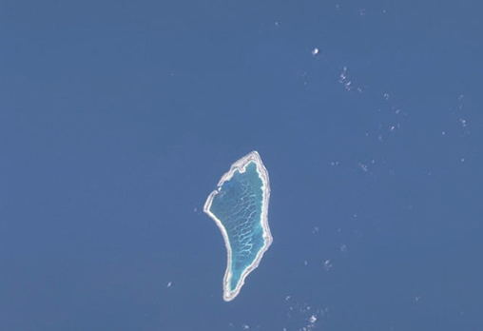
IBA 1: Proposed Abariringa (Canton) Island IBA (www.oceandots.com)
KIRIBATI IBA 2 – Enderbury Island
Name: Enderbury Island
Country/Territory: Phoenix Islands, Kiribati
Approximate Area: 5.1 km² land, 0.6 km² atoll
Altitude: 0-4m
Coordinates: 3°08′S, 171°05′W
Criteria: A1, A4i, A4ii, A4iii
Site Description: Enderbury is a low coral island surrounded by a narrow fringing reef. The island rises steeply from the ocean floor, then from the shore rises to a beach-crest before descending to a low-lying interior basin where a small hypersaline lagoon is found (orange-coloured in the above image). Vegetation on the island consists of atoll scrub and grasses with a few stands of low trees. The island is an important seabird rookery and is the most important Green Turtle (Chelonia mydas) nesting area within the Rawaki Islands (www.oceandots.com).
- Green Turtle Nesting

Species: IBA-qualifying bird populations found in the proposed IBA are:
Bird Population Category
Phoenix Petrel (Pterodroma alba) 1 A1
Red-tailed Tropicbird (Phaethon rubricauda) 200-1000 A4ii
Masked Booby (Sula dactylatra) 800-2000 A4ii
Lesser Frigatebirds (Fregata ariel) 7000-15000 A4ii
Sooty Terns (Sterna fuscata) 6000-800,000 A4i
Grey-backed Terns (Sterna lunata) 1000-10,000 A4i

Conservation Issues/Threats: Invasive species pose a threat. Feral cats have been observed causing bird mortality. Rats are also present. The island was recently named a reserve as part of the Phoenix Islands Protected Area.

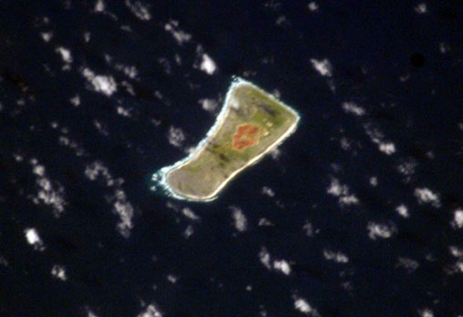
IBA 2: Proposed Enderbury Island IBA (www.oceandots.com)
KIRIBATI IBA 3 – McKean Island
Name: McKean Island
Country/Territory: Phoenix Islands, Kiribati
Approximate Area: 0.4 km² land, 0.2 km² atoll
Altitude 0-5 m
Coordinates: 03°36′S, 174°08′W
Criteria: A1, A4i, A4ii
Site Description: McKean is a low and flat, circular-shaped, coral island surrounded by a fringing reef. A species of gecko inhabits the island.

Species: IBA-qualifying bird populations found in the proposed IBA are:
Bird Population Category
White-throated Storm Petrel (Nesogregatta fuliginosa) 20-1000 A1, A4ii
Lesser Frigatebirds (Fregata ariel) 3000-85,000 A4ii
Sooty Terns (Sterna fuscata) 6000-800,000 A4i

Conservation Issues/Threats: Invasive species pose a threat. The island was recently named a reserve as part of the Phoenix Islands Protected Area.

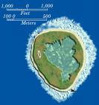

IBA 2: Proposed McKean Island IBA (www.tighar.com)
KIRIBATI IBA 4 – Nikumaroro (Gardner) Island
Name: Nikumaroro Island
Country/Territory: Phoenix Islands, Kiribati
Approximate Area: 4 km² land, 4.1 km² atoll
Coordinates: 04°40′S, 174°31′W
Criteria: A4ii
Site Description: The atoll forms an elongated structure enclosing a narrow lagoon. There are two passes that split the rim into three sections. Much of the land is thickly vegetated with Pisonia grandis, Cordia subcordata and Cocus nucifera.

Species: IBA-qualifying bird populations found in the proposed IBA are:
Bird Population Category
Red-tailed Tropicbird (Phaethon rubricauda) 50-200 A4ii
Brown Booby (Sula leucogaster) 15,000 A4ii

Conservation Issues/Threats: Invasive species pose a threat. The island was recently named a reserve as part of the Phoenix Islands Protected Area.

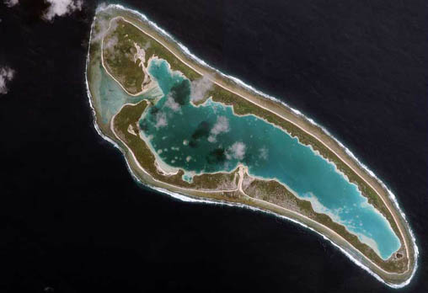
IBA 4: Proposed Nikumaroro Island IBA (www.oceandots.com)
KIRIBATI IBA 5 – Orona (Hull) island
Name: Orona Island
Country/Territory: Phoenix Islands, Kiribati
Approximate Area: 3.9 km² land, 30 km² atoll
Coordinates: 04°30′S, 172°10′W
Criteria: A4i, A4ii, A4iii
Site Description: The island has no major passages, but many small islets and openings. Sea turtles nest on the island.

Species: IBA-qualifying bird populations found in the proposed IBA are:
Bird Population Category
Lesser Frigatebirds (Fregata ariel) 1200 A4ii
Sooty Terns (Sterna fuscata) 1.2 to 3 million A4i
Grey-backed Terns (Sterna lunata) 3000 A4i

Conservation Issues/Threats: Invasive species pose a threat. The island was recently named a reserve as part of the Phoenix Islands Protected Area.

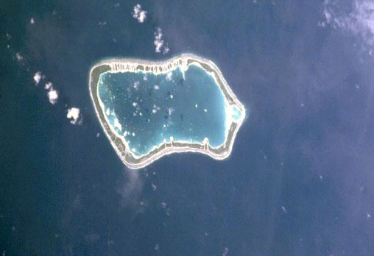
IBA 5: Proposed Orona Island IBA (www.oceandots.com)
KIRIBATI IBA 6 – Rawaki (Phoenix) Island
Name: Rawaki Island
Country/Territory: Phoenix Islands, Kiribati
Approximate Area: 0.5 km² land, 0.5 km² atoll
Coordinates: 03°43′S, 170°43′W
Criteria: A1, A4i, A4ii, A4iii
Site Description: Rawaki is a low coral island vegetated with grasses and low shrubs. It is surrounded by a raised beach crest, with the interior of the island forming a saucer-like depression. Within the central depression there is a hyper-saline lake of around 20 ha and a number of small fresh water pools — the only freshwater wetlands to be found in the Rawaki Islands (www.oceandots.com).

Species: IBA-qualifying bird populations found in the proposed IBA are:
Bird Population Category
Phoenix Petrel (Pterdroma alba) 22+ A1, A4ii
White-throated Storm Petrel (Nesofregatta fulinginosa) 40 A1, A4ii
Christmas Shearwater (Puffinus nativitatis) 1000 A4ii
Masked Booby (Sula dactylatra) 1400-3000 A4ii
Lesser Frigatebirds (Fregata ariel) 8600-50,000 A4ii
Grey-backed Terns (Sterna lunata) 2000-150,000 A4i
Black Noddy (Anous minutus) 8000 A4i
Blue Noddy (Procelsterna cerulean) 7000-10000 A4i

Conservation Issues/Threats: Invasive species pose a threat. The island was recently named a reserve as part of the Phoenix Islands Protected Area.

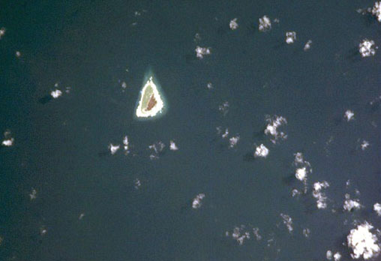
IBA 6: Proposed Rawaki Island IBA (www.oceandots.com)
KIRIBATI IBA 7 – Millennium (Caroline)
Name: Millennium Island
Country/Territory: Line, Kiribati
Approximate Area: 3.8 km² land, 2.5 km² atoll
Coordinates: 9°56′13.13″S, 150°12′41.40″W
Criteria: A1, A4i, A4ii, A4iii
Site Description: This large atoll consists of 39 islets. Most of the islets of Millennium Atoll are flat and densely vegetated with forests of Pisonia grandis, Cordia subcordata and Heliotrope (Tournefortia argentea)— representing some of the most intact and largest forests of these species remaining in the Pacific. Other areas of the atoll have scrub-type vegetation. (www.oceandots.com).
- Cordia subcordata, a rare hardwood
- Coconut Crabs

Species: IBA-qualifying bird populations found in the proposed IBA are:
Bird Population Category
Bristle-thighed Curlew(Numenius tahitiensis) 300 A1
Red-tailed Tropicbird (Phaethon rubricauda) 300 A4ii
Red-footed Booby (Sula sula) 5000-7000 A4ii
Great Frigatebird (Fregata minor) 5400-10,000 A4ii
Lesser Frigatebirds (Fregata ariel) 8600-50,000 A4ii
Sooty Tern (Sterna fuscata) .5 to 1.1 million A4i
Black Noddy (Anous minutus) 8000 A4i
Blue Noddy (Procelsterna cerulean) 7000-17,000 A4i
White Tern (Gygis alba) 4000-8000 A4i

Conservation Issues/Threats: The island is inhabited and signs of human impact are visible. Rats are present, however, the vegetation is relatively undisturbed, with a high rate of native vegetation present. The island has recently been proposed as a World Heritage Site.

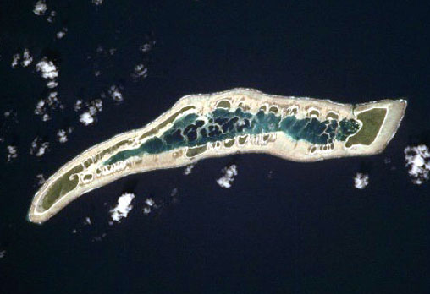
IBA 7: Proposed Millennium (Caroline) Island IBA (www.oceandots.com)
KIRIBATI IBA 8 – Kiritimati (Christmas) Island
Name: Kiritimati Island
Country/Territory: Line, Kiribati
Approximate Area: km² land, km² atoll
Coordinates: 1°53′N, 157°24′W
Criteria: A1, A2, A4i, A4ii, A4iii
Site Description: Kiritimati is the largest of the Line Islands and by total land area is the largest atoll in the world. This ancient atoll consists of a large, flat island, with a shallow tidal lagoon opening to the northwest. At the inner (eastern) end of the lagoon there are several hundred smaller, land-locked lagoons. Vegetation on the island comprises tall and dwarf scrub, grassland and herb communities, as well as large areas that have been turned over to coconut plantation (www.oceandots.com).

Species: IBA-qualifying bird populations found in the proposed IBA are:
Bird Population Category
Christmas Island Warbler (Acrocephalus aequinoctialis) 400 A2
Christmas Shearwater (Puffinus nativitatis) 2000-15,000 A4ii
Wedge-tailed Shearwater (Puffinus pacificus) 100,000-500,000 A4ii
Phoenix Petrel (Pterdroma alba) 25,000 (in 1980) A1, A4ii
White-throated Storm Petrel (Nesofregatta fulinginosa) 350 A1, A4ii
Red-tailed Tropicbird (Phaethon rubricauda) 8000 A4ii
Masked Booby (Sula dactylatra) 1000 A4ii
Red-footed Booby (Sula sula) 8500 A4ii
Great Frigatebird (Fregata minor) 10,000 A4ii
Lesser Frigatebird (Fregata ariel) 1000-5000 A4ii
Sooty Tern (Sterna fuscata) 15 to 25 million A4i
Black Noddy (Anous minutus) 14,500 A4i
Blue Noddy (Procelsterna cerulean) 2700 A4i
White Tern (Gygis alba) 5000 A4i

Conservation Issues/Threats: The island is inhabited with several thousand people and is expected to develop more. Human presence has been associated with decline of species, particularly through the introduction of alien species, including rats, cats, and dogs, and through clearing of habitat and fires. Parts of the atoll have been set aside as restricted Reserves or Key Wildlife Areas.

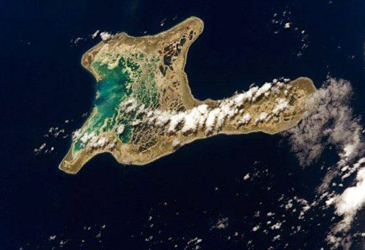
IBA 8: Proposed Kiritimati Island IBA (www.oceandots.com)
KIRIBATI IBA 9 – Malden Island
Name: Malden Island
Country/Territory: Line, Kiribati
Approximate Area: 389 km² land, 324 km² atoll
Altitude: 0-8 m
Coordinates: 4°03′S, 154°59′W
Criteria: A4ii, A4iii
Site Description: Malden is low and flat. At the centre is an extensive, shallow lagoon which contains numerous small islets and ridges composed of coral rubble. The island rises steeply from the shore in a series of sand and rubble ridges, particularly on the northern coasts, where the island is exposed to northern Pacific swells and storms. From this crest the land descends into the interior which is sparsely vegetated with scrub, low herbs and grasses. Beneath the lagoon waters of Malden are estimated to be 25 to 30 million tonnes of unconsolidated, particulate gypsum. (www.oceandots.com).

Species: IBA-qualifying bird populations found in the proposed IBA are:
Bird Population Category
Masked Booby (Sula dactylatra) 1000-3000 A4ii
Brown Booby (Sula leucogaster) 2000 A4ii
Red-footed Booby (Sula sula) 5000 A4ii
Great Frigatebird (Fregata minor) 3000 A4ii
Lesser Frigatebird (Fregata ariel) 7000 A4ii

Conservation Issues/Threats: The uninhabited island has Reserve status.

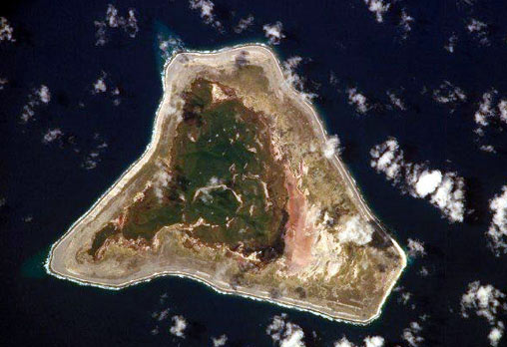
IBA 9: Proposed Malden Island IBA (www.oceandots.com)
KIRIBATI IBA 10 – Starbuck Island
Name: Starbuck Island
Country/Territory: Line, Kiribati
Approximate Area: 21 km² land, 25 km² atoll
Coordinates: 5°37′S, 155°56′W
Criteria: A4i, A4iii
Site Description: Starbuck is a low-lying island with a dry climate. The interior contains several dark-coloured saline lagoons which at times dry out completely. Starbuck rises from its reef fringed coast to a steep beach crest before descending into a slight interior depression. Due to its dry climate Starbuck is vegetated with sparse atoll scrub, herbs and low grasses (www.oceandots.com).

Species: IBA-qualifying bird populations found in the proposed IBA are:
Bird Population Category
Sooty Tern (Sterna fuscata) 2.5 to 3 million A4i

Conservation Issues/Threats: The uninhabited island has Reserve status. Cats may be present on the island.

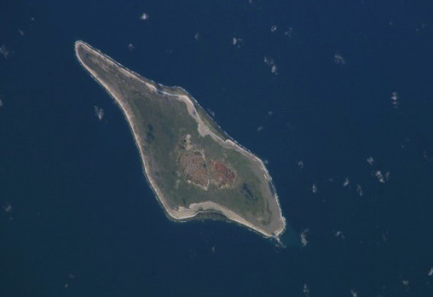
IBA 10: Proposed Starbuck Island IBA (www.oceandots.com)

KIRIBATI IBA 11 – Tabuaeran (Fanning) Island
Name: Tabuaeran Island
Country/Territory: Line, Kiribati
Approximate Area: 34 km² land, 110 km² atoll
Coordinates: 3°52′N, 159°22′W
Criteria: A1, A4i, A4ii
Site Description: Tabuaeran is a large oval-shaped atoll formation of the northern Line Islands. The atoll consists of a broad reef rim with 3 large islands and several smaller islets and sand banks. Much of the land is covered by coconut plantation. (www.oceandots.com).

Species: IBA-qualifying bird populations found in the proposed IBA are:
Bird Population Category
Kuhl’s Lorikeet (Vini kuhlii) 50 A1
Red-footed Booby (Sula sula) 3000 A4ii
White Tern (Gygis alba) 2000 A4i

Conservation Issues/Threats: The island is inhabited. The ship rat is present.

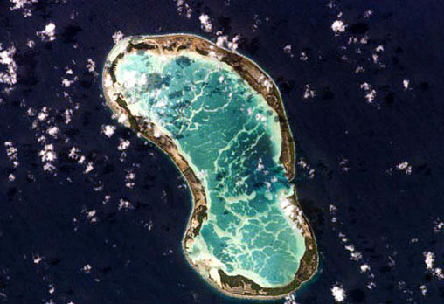
IBA 11: Proposed Tabuaeran Island IBA (www.oceandots.com)
KIRIBATI IBA 12 – Teraina (Washington) Island
Name: Teraina Island
Country/Territory: Line, Kiribati
Approximate Area: 14 km² land, 2 km² atoll
Coordinates: 4°43′N, 160°24′W
Criteria: A1, A2, A4i
Site Description: Teraina is a low-lying coral island and the northernmost member of the Line Islands. The island is unique among the Line Islands for its freshwater lake of about 2 km² and its surrounding marshlands. These freshwater environments — that occupy the area where a lagoon was once located — are considered as an outstanding biological resource. The lake has a maximum depth of around 10 m — its waters are turbid and appear as dark brown in the above image. Also found on the island are some areas of peat bogs and swampy woodland (www.oceandots.com).
- Freshwater lake and marshes

Species: IBA-qualifying bird populations found in the proposed IBA are:
Bird Population Category
Kuhl’s Lorikeet (Vini kuhlii) 1000-1600 A1
Phoenix Petrel (Pterdroma alba) Unknown A1
White-throated Storm Petrel (Nesofregatta fulinginosa) Unknown A1
Christmas Island Warbler (Acrocephalus aequinoctialis) 2000 A2
White Tern (Gygis alba) 2000 A4i

Conservation Issues/Threats: Rats, cats, and ungulates are eradication targets for the inhabited island. Rats are present but rare.

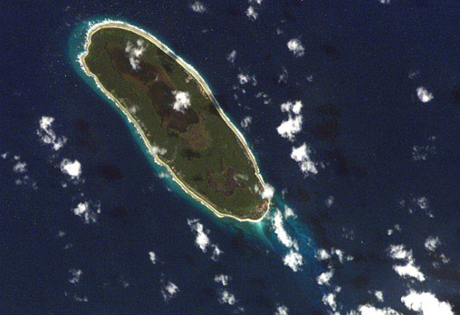
IBA 12: Proposed Teraina Island IBA (www.oceandots.com)
KIRIBATI IBA 13 – Vostok Island
Name: Vostok Island
Country/Territory: Line, Kiribati
Approximate Area: .25 km² land
Coordinates: 10°06′S, 152°25′W
Criteria: A4ii
Site Description: Vostok is a small, low coral island of the southern Line Islands (www.oceandots.com).

Species: IBA-qualifying bird populations found in the proposed IBA are:
Bird Population Category
Red-footed Booby (Sula sula) 3000 A4ii
Great Frigatebird (Fregata minor) 4500 A4ii

Conservation Issues/Threats: Vostok is a wildlife Reserve. This may be the one island where alien species pose little to no problem.

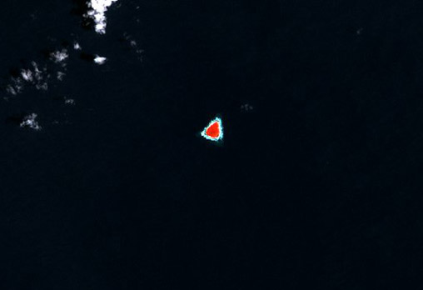
IBA 9: Proposed Vostok Island IBA (www.oceandots.com)
Chapter 7. References

Amerson, A. B. 1969. Ornithology of the Marshall and Gilbert Islands. Atoll Research Bulletin 127. 216 p.

Bakus, G. J. 1966. Changes in the avifauna of Fanning Island, Central Pacific, between 1924 and 1963. Condor 69(2): 207-209.

Bennun, L., and P. Njoroge (1999). Important Bird Areas in Kenya. Nature Kenya, The East Africa Natural History Society: Nairobi, Kenya.

BirdLife. 2003a. BirdLife EBA Factsheet s125: Gilbert Islands (secondary area). BirdLife International: Cambridge, UK. Available at http://www.birdlife.org/datazone/ebas/index.html?action=EbaHTMDetails.asp&sid=424&m=0. Accessed 30 June 2007.

BirdLife. 2003b. BirdLife EBA Factsheet s134: Northern Line Islands (secondary area). BirdLife International: Cambridge, UK. Available at http://www.birdlife.org/datazone/ebas/index.html?action=EbaHTMDetails.asp&sid=433&m=0. Accessed 30 June 2007.

Brooke, M. de L., G. M. Hilton, and T. L. F. Martins. 2007. Prioritizing the world’s islands for vertebrate-eradication programmes. Animal Conservation 10: 380-390.

Child, P. 1960. Birds of the Gilbert and Ellice Islands colony. Atoll Research Bulletin 74: 1-38.

Dahl, A. L. 1986. Review of the protected areas system in Oceania. IUCN: Gland, Switzerland.

Garnett, M. C. 1981. Conservation of seabirds in the South Pacific Region: A review. In: Croxall, J. P., P. G. H. Evans, and R. W. Schreiber (eds.). ICBP Technical Publication No. 2: Status and Conservation of the World’s Seabirds. International Council for Bird Preservation (ICBP): Cambridge, UK. P. 547-558.

Government of Kiribati. 2006. Phoenix Islands Protected Area (PIPA) Fact Sheet. Available at http://www.phoenixislands.org/pdf/pipa_fact_sheet.pdf. Downloaded 30 June 2007.

Kepler, C. B., A. K. Kepler, and D. H. Ellis. 1994. Part II: Seabirds, other terrestrial animals, and conservation. Atoll Research Bulletin 398: 1-61.

King, W. B. 1972. Conservation status of birds of Central Pacific Islands. The Wilson Bulletin 85(1): 89-103.

Lepage, D. 2007. Avibase – Bird Checklists of the World: Kiribati. Website. Available at http://www.bsc-eoc.org/avibase/avibase.jsp?region=ki&pg=checklist&list=clements. Accessed 30 June 2007.

Lovell, E. R., T. Kirata, and T. Tekinaiti. 2000. Status report for Kiribati’s coral reefs. In: Kulbicki, M. (ed.). Coral reefs in the Pacific: Status and monitoring, Resources and Management. International Coral Reef Initiative: Noumea, New Caledonia. p. 177-206. Available at http://www.icriforum.org/secretariat/pdf/111-206.pdf. Downloaded 30 June 2007.

Ministry of Environment, Lands, and Agriculture Development (MELAD). 2006. Republic of Kiribatii National Biodiversity Strategies and Actions Plan. Available at http://www.sprep.org/att/IRC/eCOPIES/NBSAPs/Kiribati_finaldraft.pdf. Downloaded 30 June 2007.

Nelson, J. B. 1978. The Sulidae. Oxford University Press: Aberdeen. 1012 p.

Obura, D. and G. S. Stone. 2002. Phoenix Islands: Summary of marine and terrestrial assessments conducted in the Republic of Kiribati, June 5-July 10, 2002. New England Aquarium: Boston, MA. Available at http://neaq2.securesites.net/scilearn/conservation/pdf/Phoenix2002.pt1.pdf. Downloaded 30 June 2007.

Perry, R. 1980. Wildlife conservation in the Line Islands, Republic of Kiribati. Environmental Conservation 7: 311-318.

Pierce, R. J., T. Etei, V. Kerr, E. Saul, A. Teatata, M. Thorsen, and G. Wragg. 2006. Phoenix Islands Conservation Survey and Assessment of Restoration of Feasibility: Kiribati. Conservation International: Samoa and Pacific Islands Initiative: Auckland. 147 p. Available at http://www.cepf.net/ImageCache/cepf/content/pdfs/ phoenix_5fislands_5fconservation_5fsurvey_2epdf/v1/phoenix_5fislands_5fconservation_5fsurvey.pdf. Downloaded 30 June 2007.

Sherley, G. 2001. Bird Conservation Priorities and a Draft Conservation Strategy for the Pacific Islands Region. SPREP: Apia, Samoa. 77 p. Available at http://www.sprep.org/att/publication/000154_Bird_conservation_and_strategy.pdf. Accessed 30 June 2007.

Sibley, F. C., and R. B. Clapp. 1967. Distribution and dispersal of Central Pacific Lesser Frigatebirds Frigata ariel. Ibis 109: 328-337.

Stattersfield, A., et al (1998). Endemic Bird Areas of the World. BirdLife International: Cambridge.

Tebano, T. 1999. Country Report for CPBD and CBD: Kiribati. Ministry of Environment and Social Development: Tarawa, Kiribati. Available at http://www.cbd.int/doc/world/ki/ki-nr-01-p1-en.pdf. Downloaded 30 June 2007.

Teeb’aki, T. 1993. Republic of Kiribati: An Introduction. In: Scott, D.A. (ed.), A Directory of Wetlands in Oceania. International Water Management Institute (IWMI): Kuala Lumpur. Available at: http://www.iwmi.cgiar.org/wetlands/pdf/Oceania/Republic%20of%20Kiribati.pdf. Accessed on 10 June 2007.

Thomas, F. R. 2002. Kiribati: “Some aspects of human ecology,” Forty years later. Atoll Research Bulletin 501: 1-40.

Watling, D. 1995. Notes on the status of Kuhl’s Lorikeet Vini Kulii in the Northern Line Islands, Kiribati. Bird Conservation International 5: 581-489.

Appendix 1. Thresholds for Seabird IBAs

Table of 1% thresholds for Pacific waterbirds (Category A4i)

English and Scientific name | Bioregion (distribution of regional population) | 1% regional population  (individuals) | 1% global population  (individuals)
Australasian Grebe Tachybaptus novaehollandiae | Pacific (Aus and Melanesia) | 10,000 | 10,000
Little Black Cormorant  Phalacrocorax sulcirostris | Pacific (Aus, NZ, NG, NC) | 10,000 | 10,000
Great Cormorant  P. carbo | Pacific (Aus, NG, NZ, Rennell, NC) | 10,000 | 20,000
Little Pied Cormorant  P. melanoleucos | Pacific (Aus, NG, Melanesia, NZ) | 10,000 | 10,000
Great (White) Egret Ardea (Casmerodius) alba | Pacific (Aus, NG, NZ) | 1,000 | 20,000
Yellow Bittern  Ixobrychus sinensis | Pacific (Micronesia) | 10,000 | 10,000
Grey Teal  Anas gracilis | Global (Aus, NZ and NC) | 20,000 | 20,000
Pacific Black Duck  Anas superciliosa | Global (Indonesia, Aus, NG, Pacific Islands, NZ) | 11,000 | 11,000
Hardhead  Aythya australis | Global (Aus, Vanuatu, NC) | 10,000 | 10,000
Pacific Golden Plover  Pluvialis fulva | East Asian flyway and Alaska migrating to central Pacific | 1,400 | 2,000
Double-banded Plover Charadrius b. bicinctus | NZ migrating north | 500 | 500
Bar-tailed Godwit Limosa lapponica baueri | East Asian flyway and Alaska migrating to central Pacific | 3,300 | 11,000
Whimbrel Numenius phaeopus variegatus | East Asian Flyway | 550 | 20,000
Bristle-thighed Curlew Numenius tahitiensis | Global (Alaska migrating to central Pacific) | 100 | 100
Grey-tailed Tattler Tringa (Heteroscelus) brevipes | Global (East Asian flyway) | 400 | 400
Wandering Tattler T. (H.) incana | Global (Alaska migrating to American W coast and Pacific) | 250 | 250
Tuamotu Sandpiper Prosobonia cancellata | Global (Tuamotu archipelago) | 6 | 6
Ruddy Turnstone Arenaria interpres | East Asian Flyway and Alaska migrating to central Pacific | 1,000 | 7,000
Sanderling Calidris alba | East Asian Flyway | 220 | 7,000
Silver Gull  Larus novaehollandiae | Global (Aus, NC) | 20,000 | 20,000
Crested Tern  Sterna bergii cristata | Pacific (Aus; small numbers in Pacific Islands) | 5,000 pairs | 6,000 pairs
Roseate Tern  S. dougallii bangsi and S. d. gracilis | Pacific (Aus, Melanesia) | 130 pairs | 500 pairs
Black-naped Tern  S. sumatrana | Pacific (Aus, Pacific Islands) | 1000 pairs | 1000 pairs
Common Tern  S. hirundo longipennis | East Asian Flyway | 10,000 | 20,000
Little Tern  S. albifrons placens and S. a. sinensis | Pacific (Aus, NG, Solomons) | 40 pairs | 1000 pairs
Fairy Tern S. nereis | Global (Aus, NC, NZ) | 30 pairs | 30 pairs
Grey-backed Tern  S. lunata | Global (Hawai’i, Micronesia, Tuamotus) | 1000 pairs | 1000 pairs
Bridled Tern S. a. anaethetus and S. a. novaehollandiae | Pacific | 1000 pairs | 7000 pairs
Sooty Tern S. fuscata | Pacific | 20,000 | 20,000
Brown (Common) Noddy Anous stolidus pileatus | Pacific | 5,000 pairs | 12,000 pairs
Black Noddy  A. minutus | Pacific | 4,000 pairs | 6,000 pairs
Blue Noddy Procelsterna cerulea | Global (tropical Pacific) | 200 pairs | 200 pairs
Grey Noddy Procelsterna albivitta | Global (sub-tropical Pacific) | 250 pairs | 250 pairs
White Tern  Gygis alba  (including Little White Tern  G. microrhyncha) | Pacific | 1000 pairs | 10,000 pairs

Table of 1% thresholds for Pacific seabirds (Category A4ii)
In most cases follow Brooke (2004a) as the most authoritative guide, updating previous BirdLife estimates. Where BirdLife (2004b) has estimated numbers for threatened species, these figures are used as they are likely to be more accurate and more precautionary than figures in Brooke (2004a).

English and Scientific name | Global population estimate | 1% threshold
Wedge-tailed Shearwater P. pacificus | 5,200,000 individuals | 10,000 pairs
Christmas Shearwater  P. nativitatis | 50,000 pairs | 500 pairs
Little Shearwater  P. assimilis | 300,000 pairs | 3,000 pairs
Audubon’s Shearwater  P. lheKiribatinieri | 150,000 pairs | 1,500 pairs
Heinroth’s Shearwater  P. heinrothi | 500 individuals | 1 pair
Bulwer’s Petrel  Bulweria bulwerii | 750,000 individuals | 1,500 pairs
Tahiti Petrel Pseudobulweria rostrata | 10,000 pairs | 100 pairs
Beck’s Petrel P. becki | 25 individuals | 1 pair
Fiji Petrel P. macgillivrayi | 25 individuals | 1 pair
Black-winged Petrel Pterodroma nigripennis | 9,000,000 individuals | 20,000 pairs
Collared Petrel  P. brevipes | 5,000 individuals | 10 pairs
Gould's Petrel  P. leucoptera | 5,000 pairs | 50 pairs
Phoenix Petrel  P. alba | 5,000 individuals | 10 pairs
Henderson Petrel  P. atrata | 16,000 pairs | 160 pairs
Kermadec Petrel  P. neglecta | 55,000 pairs | 550 pairs
Herald Petrel  P. heraldica | 50,000 pairs | 500 pairs
Murphy’s Petrel  P. ultima | 265,000 pairs | 2,650 pairs
White-bellied Storm-petrel  Fregetta grallaria | 100,000 pairs | 1000 pairs
Polynesian Storm-petrel Nesofregetta fuliginosa | 1700 pairs | 17 pairs
Red-tailed Tropicbird Phaethon rubricauda | 32,000 individuals | 80 pairs
White-tailed Tropicbird P. lepturus | 50,000 individuals | 125 pairs
Masked Booby  Sula dactylatra | 200,000 individuals | 500 pairs
Red-footed Booby  S. sula | 600,000 individuals | 1,500 pairs
Brown Booby  S. leucogaster | 200,000 individuals | 500 pairs
Great Frigatebird  Fregata minor | 340,000 individuals | 850 pairs
Lesser Frigatebird  F. ariel | 200,000 individuals | 500 pairs

Appendix 2. Key Stakeholders and Advocated Dissemination List

Greg Stone, Vice President Global Marine Programs
New England Aquarium
Central Wharf
Boston, MA 02110 USA
gstone@neaq.org

Raymond Pierce
Eco Oceania, Ltd.
Mt. Tiger Road
RD 1 Onerahi 0192
New Zealand
raypierce@xtra.co.nz

Sue Miller Taei, Marine Program Manager
Pacific Islands
Conservation International
staei@conservation.org

Takubu Teroroko,
Permanent Secretary, Ministry of Environment, Lands and Agricultural Development (MELAD)
Chair, Kiribati Interagency Phoenix Island Committee
Ministry of Environment, Lands, and Agricultural Development
tukabut@melad.gov.ki

Ministry of Environment, Lands, and Agricultural Development
PO Box 234
Bikenibeu, Tarawa
Kiribati

Biodiversity and Conservation Officer
Environment and Conservation Division
PO Box 234
Bikenibeu, Tarawa
Kiribati

Ministry of Home Affairs and Rural Development
PO Box 75
Bikenibeu, Tarawa
Kiribati

Atoll Research Programme
PO Box 101
Bairiki, Tarawa
Kiribati

Wildlife Conservation Unit, Ministry of Line and Phoenix Islands
MLPG
London, Kiritimati Island
Kiribati

Appendix 3. Recommended changes to the IUCN Red List

The Line Islands (Christmas Island) Warbler (Acrocephalus æquinoctialis) is currently listed as LC – Least Concern (August 2007). However, an examination of the literature over time indicates that the population may be in decline.

Kiritimati
1966 – Common
1972 – 400
1980 – Scarce in vicinity of settlement

Sherley (2001) also noted a general decline in all bird species in Kiritimati.

Tabuaeran
1972 – Extirpated from island

Teraina
1972 – 2000
1981 – Common

Even though this data is sparse, it seems to indicate that the bird is in decline. Regardless of an evident decline, the small population (2,400 in 1972 on two islands) and fragmented extent (2 islands (formerly 3) separated by hundreds of kilometers) are reason for concern. This report suggests a more targeted review of the species with the possibility that it be uplisted to Near Threatened.

An Endemic Bird Area (EBA) is defined as an area which encompasses the overlapping breeding ranges of restricted-range bird species, such that the complete ranges of two or more restricted-range species are entirely included within the boundary of the EBA (Stattersfield, et al., 1998).

