The Pacific Regional Environment Programme

In 1993 Pacific Leaders came together to formally establish the Pacific Regional Environment Programme (SPREP), and confirm its secretariat as the Pacific’s primary intergovernmental organisation, charged with supporting the work of Members to address the region’s environmental management challenges.

SPREP is a partnership of 26 Members scattered over thousands of kilometres of ocean but sharing common elements of culture, history, and environment.

For thousands of years the people of the Pacific region have relied on rich natural resources for their survival. The marine environment sustains them, and they depend on it for food, transport, traditional practices, and economic opportunity. Lands and forests of the Pacific islands have nurtured their inhabitants by providing food, fuel, and shelter. Indigenous cultures and their traditions over many generations have developed a rich heritage of stewardship over natural capital, of traditional management practices, and of knowledge.

There has also been a long history of ecosystem modification and species extinction across the Pacific; this trend has accelerated with modern development pressures. While climate change is at the forefront of regional concerns, ongoing issues of pollution and waste, land use changes such as deforestation which can undermine long-term sustainable development, population growth, and marine resource depletion continue to threaten the long-term viability of island economies.

Ecosystem-based approaches must underpin development if Pacific island societies are to establish a balance between the aspirations of societies and the sustainability of the ecosystem services that support them. Equally, behavioural change is needed for addressing issues such as waste management and pollution control.

Pacific Leaders showed great foresight in establishing SPREP’s mandate “to promote co-operation in the Pacific region and provide assistance in order to protect and improve its environment and to ensure sustainable development for present and future generations”. The SPREP secretariat works to provide our 21 Pacific island Members with technical advice and support for capacity building for the region’s environmental and development priorities, and promotes sustainable development and co-operation in the region. SPREP is also a member of the Council of Regional Organisations of the Pacific (CROP) and works with its peer CROP agencies to serve the people and governments of the region.

While much progress has been made by SPREP Members to address environmental issues across the region, enormous challenges still remain. Dominant among these are the increasing impacts of climate change, which overlay and make worse the range of other environmental management issues that Pacific island Members have also prioritised. Addressing these issues will require a balanced approach that delivers solutions that focus on all critical sectors. Now more than ever we look to our partnership in SPREP to help us manage these challenges.

Our vision remains the same as in our 2011-2015 Strategic Plan: “The Pacific environment sustaining our livelihoods and natural heritage in harmony with our cultures.”

Development of the Strategic Plan

The 2017-2027 Strategic Plan builds on the successes and lessons learned in the implementation of the 2011-2015 Strategic Plan. SPREP has used these lessons together with an extensive consultation process with Members, partners and Secretariat to develop this strategic plan. The plan has also been guided by Member commitments to the strategic directions for the region set out in the Framework for Pacific Regionalism, the priorities defined by the SAMOA Pathway, commitments to the Sustainable Development Goals, and other important regional and global commitments.

Fundamental to development of this strategic plan has been the need for a more integrated, focussed, programmatic approach to addressing strategic priorities. This will improve service delivery to Members and the implementation of SPREP's new roles as a Regional Implementing Entity for the Adaptation Fund and the Green Climate Fund. The Pacific Climate Change Centre to be established at SPREP will also enhance service delivery across the Pacific island region as a centre for collaboration and partnerships, as we fulfil our mandate given by our Pacific Leaders on environmental management and climate change coordination in the Pacific.

SPREP Values

SPREP approaches the environmental challenges faced by the Pacific guided by four simple values: These values guide all aspects of our work.

We value the Environment

Our most distinguishing feature is our firm focus on environmental conservation and sustainability. SPREP understands that the environment sustains livelihoods and development across the Pacific in many ways – and particularly in terms of health, economy, and culture. SPREP stands for the sustainable management of the environment and its intricate network of ecosystems and biodiversity to ensure it continues to support unique and thriving Pacific livelihoods for generations to come. SPREP will promote environmentally sustainable practices. We will develop expertise, share knowledge, deliver practical environmental outcomes and build the capacities of vulnerable Pacific island Members to manage their environment, reduce risks and adapt to adverse global changes.

We value our People

SPREP exists to support the people of the Pacific. Our vision is centered on Pacific livelihoods and so too is our approach. SPREP is driven by the values and priorities of our 21 Pacific Islands Countries and Territories taking into consideration the diverse gender and cultural priorities. We celebrate the diversity across our wide ocean and within island communities and we will strive to embrace diversity in our work. We will talk, listen, and work together to pursue our vision.

We value high quality and targeted Service Delivery

SPREP prides itself on delivering the best practice, evidence based programmes to service the priority needs of Members and develop common regional goals and approaches. We will work as a team promoting partnerships with related organisations, and be flexible to cope with change to produce high quality outcomes.

We value Integrity

The SPREP Secretariat will be a wise steward of the resources entrusted to it, remain impartial and apolitical in our interactions with Members, and act fairly and equitably. We will maintain high standards of ethical conduct.

Strategic Focus

The 2017-2027 SPREP Strategic Plan:

- Prioritises 4 regional goals with supporting objectives. Together these define the core priorities and focus of SPREP for the next 10 years:
  - Climate Change Resilience
  - Ecosystem and Biodiversity Protection
  - Effective Waste Management
  - Good Governance

- Confirms the role that SPREP occupies in the Pacific Region, and the added value and approach that SPREP will take in carrying out its role.
- Identifies Organisational Goals to frame how the Secretariat will strengthen its policies, processes and capacity to effectively deliver on its mandate.

Diagram 1: The contribution of Regional Goals to Sustainable and Healthy Pacific Communities
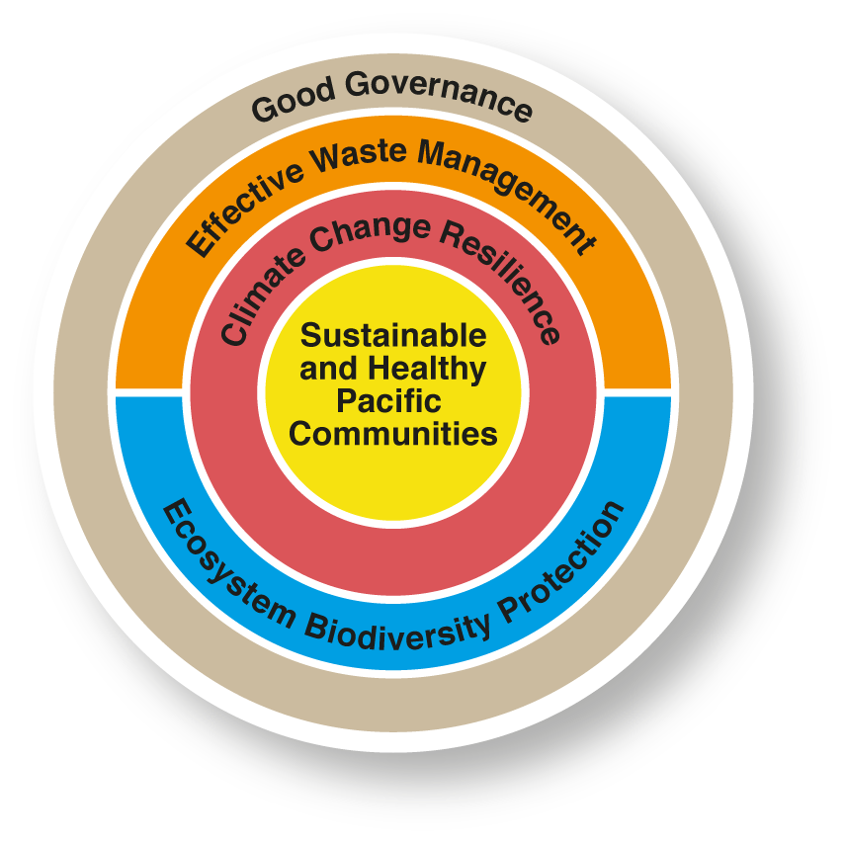

Regional Goals

As the regional intergovernmental environment organisation, the role of SPREP is to facilitate and implement activities with Members and partners to achieve regional, national and sub-national outcomes. SPREP’s overall assistance to members will be delivered through agreed regional environment goals and objectives that respond to Members’ environmental priorities and sustainable development goals. They will be addressed through regionally appropriate and strategic cross-cutting approaches, including:
- strengthening ecosystem based approaches to sustainable development
- environmental advocacy, awareness and understanding
- environmental leadership
- gender and human rights
- combining traditional knowledge with technical capacity.

Regional Goal 1. Pacific people benefit from healthy and resilient island and ocean ecosystems
Healthy ecosystems are foundations for sustainable development and adaptation and resilience to climate change. Pacific environments also support globally significant levels of biodiversity that form part of our critical ecosystems and support significant tourism economies. Under its vision and mandate, SPREP provides regional leadership, technical guidance and serves as a conduit for member states in optimising the implementation of several global MEAs and regional environmental frameworks such as the Noumea (or SPREP) Convention, the Framework for a Pacific Oceanscape and the Framework for Nature Conservation and Protected Areas in the Pacific Islands Region.

Objectives

1.1 Achieve healthy and productive oceans that support food security and sustainable development through effective management and protection of marine and coastal ecosystems, and mitigate the impacts of fisheries activities to ensure healthy populations of threatened species.
1.2 Conserve and sustainably use marine, coastal, and terrestrial ecosystems and biodiversity consistent with regional and international commitments.
1.3 Prevent the extinction of threatened species and improve and sustain their conservation status.
1.4 Significantly reduce the socio-economic and ecological impact of invasive species on land and water ecosystems, and control or eradicate priority species.

Regional Goal 2. Pacific people benefit from strengthened resilience to climate change
For Pacific island Members, the economic, social and environmental costs of climate change and disasters are high and forecast to increase. As the lead coordinator for climate change in the region, SPREP continues to lead the region’s response to climate impacts. SPREP promotes integration of climate change adaptation and disaster risk management through capacity building and within an ecosystem based approach. SPREP is a key conduit for our members to make effective use of the UNFCCC, and Conference of the Parties processes, the Paris Agreement and other global climate initiatives. At the regional level SPREP promotes the draft strategy on Resilient Development in the Pacific: An Integrated Approach to Climate Change and Disaster Risk Management (SRDP) to guide our collaborative approach with regional organisations, donors and the UN to strengthen resilience to climate change. Increasing the access to climate change finance is a high priority for Pacific island Members and SPREP will support Members through its role as an accredited entity to the Adaptation Fund and the Green Climate Fund and through other sources. As host of the Pacific Climate Change Centre, SPREP will deliver on its mandate as coordinator of Pacific climate change action.

Objectives

2.1 Strengthen the capacity of Pacific Island Members to lead, prioritise, and manage national climate change adaptation, mitigation (NDCs) and disaster risk reduction in fulfilment of their national environment and development goals and their voluntary and legal obligations under regional and international agreements.
2.2 Minimise multiple pressures on vulnerable Pacific Island ecosystems by implementing ecosystem-based approaches to climate change adaptation, including ocean acidification and sea level rise, to sustain biodiversity and the provision of ecosystem services that support livelihoods and sustainable development.
2.3 Enhance National Meteorological and Hydrological Services capacity in weather
forecasting, early warning systems, long term projections and improved climate services to support Members’ decision-making and coordination through the Pacific Meteorological Council.

The establishment of the Pacific Meteorological Council has resulted in significantly increased support for National Meteorological Services since 2011. SPREP also hosts the regional office of the World Meteorological Organisation, making the Secretariat the regional hub for meteorological services. Support from the Government of Japan in partnership with the Government of Samoa to establish the Pacific Climate Change Centre (PCCC) on the SPREP campus in Samoa enables SPREP to further enhance its meteorological support to members.

2.4 Support Pacific Island Members to access and manage climate change finances and their national accreditation processes.

As a Regional Implementing Entity for the Adaptation Fund, Green Climate Fund and via other financing mechanisms, SPREP is able to maximise access to and leverage climate finance for members.

2.5 Support Pacific Island Members to develop policy responses to issues of loss and damage, and climate change and disaster induced population mobility.

Regional Goal 3. Pacific people benefit from improved waste management and pollution control

SPREP has lead responsibility on regional coordination and delivery of waste management and pollution control action and uses the strategic management framework, Cleaner Pacific 2025, in guiding regional cooperation and collaboration. SPREP promotes evidence-based strategic planning within countries to develop strategies that address emerging priorities and opportunities in locally appropriate ways. In assisting Pacific island countries and territories to build capacity to implement waste, chemicals and pollutants programmes SPREP continues to focus on in-country human resource support, technical cooperation and a learn-by-doing approach for longer term self-sufficiency. SPREP also works with key international and regional partners to achieve greater integration of sustainable funding and support mechanisms into waste, chemicals and pollution management programmes.

Objectives

3.1 Minimise the adverse impacts of chemicals and all wastes on human health and the environment through environmentally sound life-cycle management in accordance with agreed regional and international frameworks including Cleaner Pacific 2025, and significantly reduce the release of pollutants to air, water, and soil.
3.2 Strengthen national, regional and international mechanisms for waste management including for chemicals, hazardous wastes, ship and aircraft generated waste, marine plastic litter and other marine debris.
3.3 Recover resources from waste and pollutants through composting (nutrient recovery), recycling (material recovery), energy recovery and other measures in order to minimize waste and contribute to economic and social development.
3.4 Improve waste and pollution monitoring of receiving environments to enable informed decision-making on appropriate measures to protect human health and the environment and to reduce associated environmental damage.

Regional Goal 4. Pacific people and their environment benefit from commitment to and practice of good governance
SPREP plays a lead role in assisting countries to develop capacity in environmental governance, policy development, planning, monitoring and reporting for sustainable environmental outcomes and to keep pace with socio-economic development. This also includes strengthening and supporting political leadership on environmental issues in the region through initiatives such as the Framework for a Pacific Oceanscape, and assisting leaders and their delegations in their advocacy in international fora.

SPREP continues to provide key support to Members in planning for implementation of their multilateral environmental agreement (MEA) requirements and other enabling frameworks, development of legislation, training and capacity building for environmental impact assessment and spatial planning. This includes responsibilities to develop regional standards for monitoring and reporting environmental change at both national and regional scales.

Objectives

  - Strengthen national sustainable development planning and implementation
systems including through use of EIA, SEA, and spatial planning.
4.2 Improve national capacity for good environmental governance supported by technical assistance for development of policy and legislation, and in support of implementation of Members’ international and regional commitments.
4.3 Strengthen environmental data collection, monitoring and analysis nationally and regionally.
4.4 Strengthen access to funding mechanisms and using funds effectively and efficiently to deliver required interventions.
  - Strengthen synergies between science, policy and traditional and local knowledge to
guide decision making.

SPREP Role and Focus

The SPREP Secretariat has a unique role within the regional architecture defined in the SPREP Mandate: to promote co-operation in the Pacific region and provide assistance in order to protect and improve its environment and to ensure sustainable development for present and future generations. In carrying out its role, the Secretariat draws upon its rich experience in the Pacific including through established relationships with governments and key stakeholders to add value, complement and strengthen the environmental management functions of our Members. SPREP seeks to:

5.1 Provide responsive high quality technical and capacity backstopping to Members

SPREP will work with and through Member governments to build, transfer, and supplement priority skills needed by Members to implement their national environmental priorities and meet their international commitments. The Secretariat will use competitive and transparent staff recruitment and retention of expert staff.
5.2 Lead and support coordination and advocacy

SPREP will use its convening power to influence regional and international dialogues and negotiations to the benefit of Pacific regional environmental management priorities. The Secretariat will use its expertise, networks, and partnerships to advocate for regional and international priorities with Members.

5.3 Broker partnerships and collaborations

SPREP Members individually and through the Secretariat will seek to strengthen established partnerships and forge new ones in order to best serve the environmental needs of Pacific communities. In doing this, we will continue to collaborate with other CROP agencies to make best use of the financial, human and capital resources applied to Pacific Islands’ environmental priorities and deliver agreed environmental outcomes which have impacts on the environment, sustainable development and the well-being of our communities.

The Secretariat will take the lead in coordinating partnerships in core areas of mandate (climate change, sustainable development, environmental management) and support collaboration where there are environmental components within other agencies’ core areas of responsibility.

5.4 Provide regional services and access to resources

Financial resources and capacities are generally limited in the region and often insufficient to address the scale and significance of the challenges being faced. SPREP is well positioned to leverage additional resources with other partners and donors. SPREP is also able to mobilise practical project management expertise and support.

The Secretariat will operate as a Regional Implementing Entity for major funds, and a conduit to international partners and resources on behalf of Members.

5.5 Act as a repository and manager of data information and knowledge

The Secretariat will provide and manage regional repositories of environmental data, knowledge, and information as requested by, and for dissemination to, Members, including via portals on the SPREP website (Pacific Climate Change Portal, Pacific Island Protected Areas Portal), and in support of National Environmental Strategies and plans.

SPREP is the Pacific hub for: meteorological and climate services; the Asia-Pacific Adaptation Network (APAN); and the Commonwealth Pacific node for Climate Change Finance.

6. SPREP Organisational Goals and objectives

The future directions outlined in this Strategic Plan will require the SPREP Secretariat to strengthen and realign its institutional capacities, competencies and systems to best support Members by delivering more integrated, responsive and cost-effective services to members and partners, and better coordinating regional efforts.

The need for sustainable funding continues to be a key challenge that requires immediate focus. SPREP will also need to embrace new and bold approaches to other significant challenges including structural reorganisation, capability building and ongoing change management to capitalise on new opportunities and maximise available resources. Over the next ten years we will adapt, respond and develop to ensure the trust and confidence of our members, partners and stakeholders.

Organisational Goal 1:

SPREP has information, knowledge and communications systems that get the right information to the right people at the right time and influence positive organisational and environmental change.

The role of the Secretariat as a clearing-house of information and knowledge is fundamental to ensuring that essential technical, scientific information and traditional knowledge is available our Members when needed.
Effective SPREP external communications and advocacy is vital in protecting and sustainably managing Pacific environments and informing relationships with current and potential new Partners.

Objectives

1.1 Share and use knowledge through the development and maintenance of reliable systems and processes for the effective collection, storage and access to critical information.
1.2 Influence positive behaviour change within SPREP and its stakeholders through persuasive, purposeful and integrated communications.
1.3 Improve quality and interoperability of information and communications technology infrastructure in the region.

Organisational Goal 2:

SPREP has multi-disciplinary processes in programme delivery and in supporting Members to develop national and regional policies and strategies.
The SPREP Secretariat will develop and deliver integrated programmes. When we combine our disciplines, perspectives and strengths we deliver the best services to Members and the most transformative environmental leadership in the region. Integrated programme approaches deliver strategic and aligned results in Member countries and focus the resources available to SPREP on the strategic areas of change.

Objectives

2.1 Promote integrated programme approaches to address environmental management challenges.
2.2 Strengthen SPREP’s learning and outcomes reporting framework, integrating organisational and environmental performance.

Organisational Goal 3:

SPREP has a reliable and sustainable funding base to achieve environmental outcomes for the benefit of the Pacific islands region.

The SPREP Secretariat will look for greater cost-effectiveness and efficiencies, and better integrate financial and programme planning to retain the confidence and trust of our members, donors and partners. We will continue to execute the checks and balances that contribute to our credibility as the region’s premier environmental organisation.

Objectives

3.1 Manage funds efficiently and transparently through effective financial, risk management and audit systems, integrated with programme management, monitoring, evaluation and reporting systems.
3.2 Build effective, strategic, long-term relationships with new and existing donors through regular communications, including high-level discussions and meetings.
3.3 Build the capacity of SPREP as a Regional Implementing Entity for climate change and as a conduit for other environmental funding mechanisms.

Organisational Goal 4:

SPREP is leading and engaged in productive partnerships and collaborations.

The SPREP Secretariat is committed to effective coordination of regional efforts within SPREP’s mandated areas of focus and to collaborating with other regional organisations and partners who provide expertise and capacity that we may not have. We understand that we act as a gateway for partners at the national level, and will continue to build genuine and productive partnerships that support advancement of Members’ national and regional priorities. We will improve the way we manage partnerships, seeking to make them meaningful, mutually beneficial and focussed on achieving positive environmental outcomes.

Objectives:

4.1 Improve SPREP partnerships, including development of mutually beneficial MOUs with clearly defined roles for both partners and measurable results that are regularly followed-up.
4.2 Strengthen SPREP’s reputation and capacity to lead productive regional partnerships that achieve positive environmental outcomes.

Organisational Goal 5:

SPREP has access to a pool of people with the attitudes, knowledge and skills to enable it to deliver on its vision.

Our people are our most important resource. Our priority is to continue to recruit and retain skilled and talented people who have SPREP’s best interests at heart. The international employment market continues to be highly competitive and workforces are becoming more mobile. With an ever-changing global market, we need to continuously build staff capacity and capability to respond to change and new developments as well as to continue to maintain the respect and confidence of our members, partners and donors. We also need to embrace new and different cost-effective approaches to remain competitive. The Secretariat will continue to ensure it provides a positive and healthy environment for its staff and members to work in.

Objectives

5.1 Recruit and retain people who contribute their skills and knowledge in a collaborative manner to execute SPREP’s strategic plan in an effective and efficient manner.
5.2 Build our human resource capability and capacity through continuous professional development within an empowering professional workplace culture.
5.3 Build a constructive, empowering and results-oriented culture where working as a collaborative team that respects and values each other is the norm.

Enabling Principles for Prioritisation

In the delivery of its key tasks, SPREP will operate according to the following principles:

7.1 SPREP mandate for improved environmental management and sustainable development
SPREP will focus effort on areas related to environmental management.

7.2 Relevance to regional and national contexts and priorities
SPREP will prioritise work that supports delivery of national priorities or strategies; regional strategies and frameworks as well as international obligations.

7.3 SPREP's strategic environmental technical expertise, experience, and regional relationships add value
SPREP will deliver work for which it has the mandate and technical expertise.

7.4 Return on investment
SPREP will adopt approaches and pursue work which has a high likelihood of sustained outcomes and represents good value for money. It will support countries to do the same through adoption of cost benefit analysis and other approaches. SPREP will work to ensure the financial sustainability of the organisation and leverage its core funding to attract new and additional resources.

8. Implementation and Monitoring

Implementation, monitoring, evaluation and reporting of the Strategic Plan will be the responsibility of the Secretariat, in collaboration with Members. Through a structured and integrated planning, implementation and reporting process, SPREP will ensure a high level of transparency and accountability, while also supporting a culture and practice of evaluation, reflection and continuous improvement. SPREP’s approach to planning and monitoring is defined in two key documents:

- Performance Implementation Plan
- Results Planning, Performance Reporting and Learning Framework

8.1 Performance Implementation Plan

Implementation of the Strategic Plan will be guided by a 2 year Performance Implementation Plan (PIP). The PIP will provide a strategic plan of action to operationalise this strategic plan. The PIP will be reviewed and updated every two years, in-line with the SPREP Meeting Schedule. The PIP will:

- Describe the focus and approach of the work SPREP will do over the 2 year period to progress the Regional and Organisational Objectives.
- Set expectations for SPREP short term results delivery and performance.
- Set targets, indicators and activities for the 2-year PIP timeframe.
- Establish simple Country Action Plans, which describe the key priorities for each Member country that will be delivered during the 2 year period.
- Describe key strategic, operational, administrative and other matters that need careful and deliberate management. Issues to be included in the PIP will be informed by input from the SPREP Troika, Audit Committee, and SPREP Meeting.

The PIP will be reviewed, updated and reported every 2 years (at the SPREP Meeting) and serve as the basis for more detailed annual work programmes and budgets.

8.2 Results Planning, Performance Reporting and Learning Framework

The Results Planning, Performance Reporting and Learning Framework (the Results Framework) describes how results will be monitored, reported on, and lessons learned identified and applied. It will support transparent, efficient and accountable planning processes, and provide a framework to investigate, and understand the effectiveness and impact of SPREP’s work – in particular it will support SPREP to understand the strategies and modalities which are most effective in supporting environmental sustainability. The Framework will:

- Define the planning cycle of SPREP providing clarity of roles, responsibilities and linkages between planning and reporting processes.
- Define key monitoring, evaluation and reporting activities. How SPREP will monitor, evaluate, and report on progress towards goals and objectives.
- Describe SPREP’s approach to learning and continuous improvement.

Diagram 2: Implementation and Monitoring the Strategic Plan (10 Year)
Semi
Annual
Annual
Biennial
5 Yearly

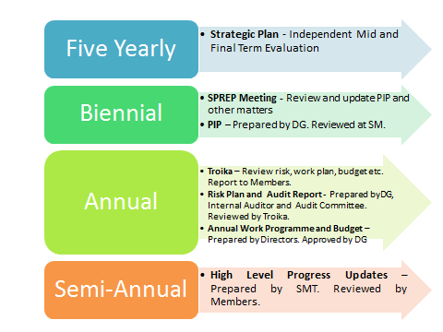

Governance

The new strategic plan will be governed and monitored through the SPREP Meeting and periodically through the SPREP Troika, Friends of the Chair and the Audit Committee. The SPREP Meeting will convene every two years. The role of the SPREP Troika and the mechanism of the Friends of the Chair and Audit Committee will be enhanced to reflect adequate representation of members.

Strategic areas of change

The overall outcomes of the strategic plan will be achieved by effecting change in each of the following 4 strategic areas of change:

International standards and monitoring
PICTs play an important role in helping the international community set targets and standards. Once set, Members must implement their commitments and report on progress. Bringing about strategic change in this area will involve helping SPREP Members to:
- Advocate in and report to international fora
- Implement their commitments
- Assess progress in meeting their targets
- Report internationally on their commitments

Community/public awareness and behaviour
Changing the perceptions and practices of individuals, communities, organisations, and governments is fundamental to achieving sustained, resilient development, as well as resilient environments and the lifestyles and cultures that depend on them, in the face of growing environmental challenges from outside and within our region. SPREP must work collaboratively to bring about the necessary changes that will help us provide a sustainable foundation for present and future generations.
Policy and legislative frameworks
Policies and legislative frameworks, whether customary, governmental, or institutional, guide and support the changes we need to make for sustainable and resilient futures.
Institutional capacity
Our Pacific countries and territories are small in land area, and in our capacity to manage the scale of environmental challenges that face us. Our national and regional institutions struggle to guide Members’ actions to implement change. Building capacity for environmental management remains a key priority for our region.
Diagram 3: Schematic representation of the SPREP Strategic Plan

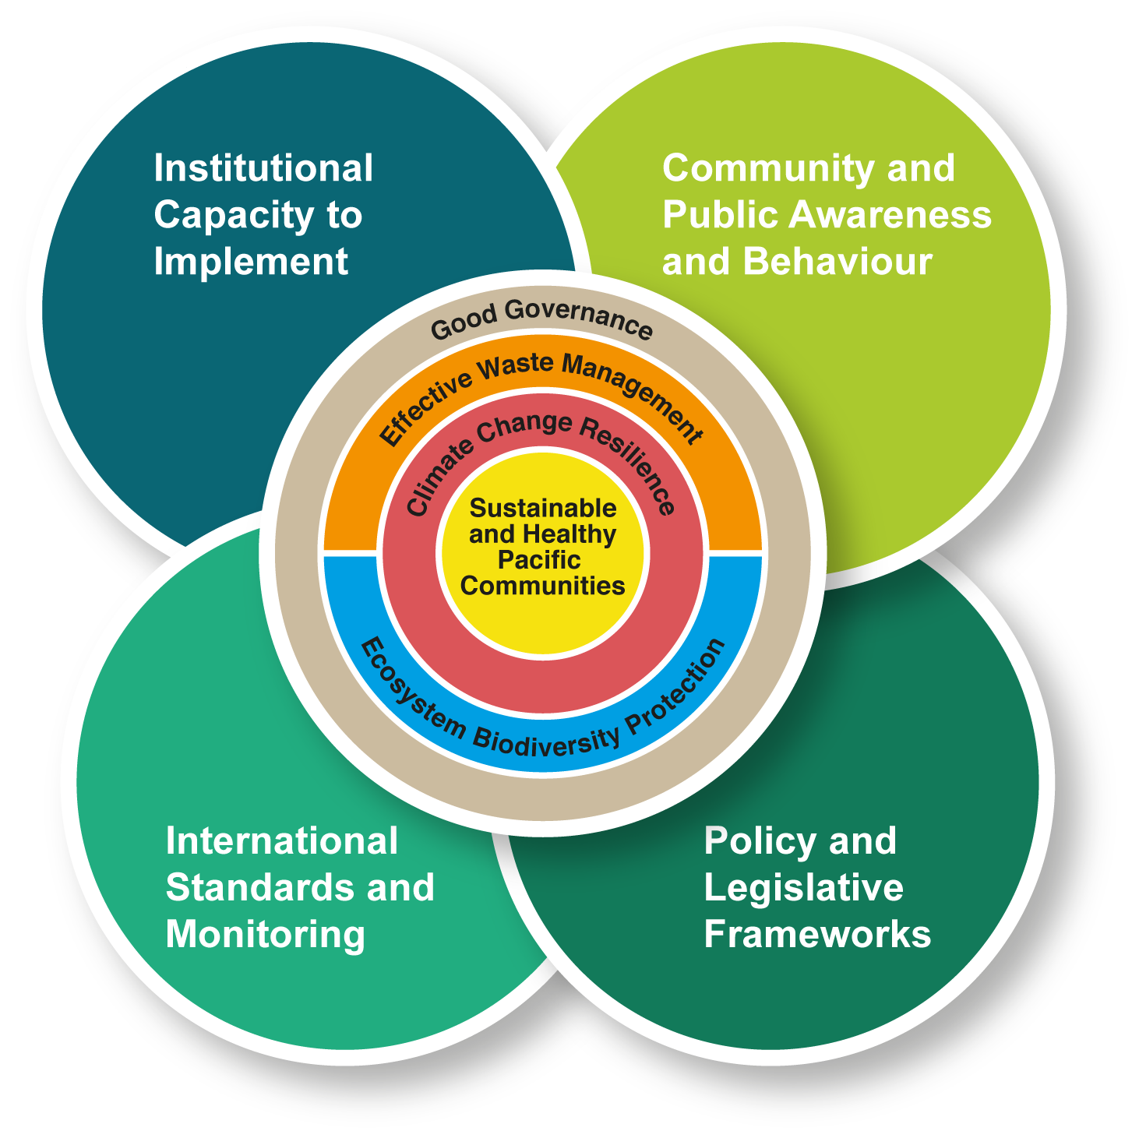

American Samoa, Australia, Cook Islands, Federated States of Micronesia, Fiji, France, French Polynesia, Guam, Kiribati, Marshall Islands, Nauru, New Caledonia, New Zealand, Niue, Northern Mariana Islands, Palau, Papua New Guinea, Samoa, Solomon Islands, Tokelau, Tonga, Tuvalu, United Kingdom, United States of America, Vanuatu, and Wallis and Futuna.
Small Island Developing States Accelerated Modalities of Action
‘Islands’ refers terrestrial, coastal lagoon and nearshore marine waters that comprise the totality of island environments; ‘oceans’ refers to marine ecosystems that extend from island nearshore waters to EEZ boundaries and areas beyond national jurisdiction.
CBD Aichi Targets, CBD Nagoya Protocol on ABS, Regional Framework for Nature Conservation and Protected Areas, national and international law
Nationally Determined Commitments in the context of reducing greenhouse gas emissions (PA).
Within the context of the SRDP, Sendai Framework and for PICs only in the context of the Paris Agreement (PA)
Through SPREP’s Regional Implementing Entity (RIE) for the Green Climate Fund (GCF) and Adaptation Fund (AF) including through the Global Environment Facility (GEF) and from other sources.
Process of decision-making and the process by which decisions are implemented (or not implemented). In an environmental context this includes commitment to and implementation of international conventions, legislation, planning, monitoring and decision-making based on relevant information and participatory consultation with stakeholders, and other relevant tools and processes.

