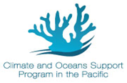
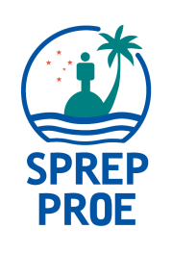
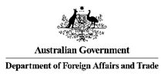
Media coverage:
4th Pacific Meteorological Council
2nd Pacific Meteorological Ministers Meeting
14 - 18 August, 2017 │ Honiara, Solomon Islands
Pacific islands regional media workshop:
Information Making Impact: Pacific Island Media and Meteorological Services
9 – 11 August, 2017 │Honiara, Solomon Islands

Application Form:
If you are interested to be part of this crucial and dynamic opportunity, please fill out the form along with providing us with the relevant documents in the checklist and send back to sprep@prep.org, with Application for Regional Media Training in the subject line by close of business Samoa time, 19 July 2017.

If you are a Pacific island journalist based in Solomon Islands we will be sending a separate application for you to be part of this training in due course.

By completing and submitting this form, I understand all expectations required of me if selected and if selected I agree to having my stories shared by SPREP, noting they will use my byline and name of media organisation.
Note – this application form MUST be accompanied with the following:
- A letter from your Editor outlining support for your application and commitment to publish/broadcast stories submitted by you from 9 – 18 August, 2017.
- Two copies of stories developed by you
- A copy of your personal details page of your passport you plan to travel under
- A brief resume

Name and Position
Media Organisation Name and website
Country

Email contact
Phone number (Work)
(Personal)
Gender |  | Number of years working as a reporter
Date of birth |  | Postal address
Countries you have valid vias for travel plans
Your Media genre
(TV, print, radio or online, or all)
Equipment you will be coming with – (laptop, recorder, camera etc)
Media History

Brief paragraph - what you hope to achieve by taking part in this media opportunity
Brief paragraph as to how you plan to use this training upon your return home

