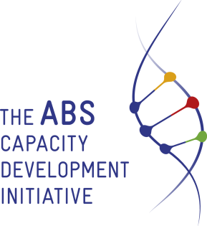

REGIONAL PROJECT STEERING COMMITTEE MEETING
“ACCESS AND BENEFIT SHARING (NAGOYA PROTOCOL) REGIONAL PROJECT”

JOINT REGIONAL PROJECT STEERING COMMITTEE
ACCESS AND BENEFIT REGIONAL PROJECT
& ABS CAPACITY DEVELOPMENT INTIATIVE PACIFIC COMPONENT
Apia- Samoa, 31 January 2020
Online Conference & face to face

TENTATIVE AGENDA

Time (TBC)  Apia Time | Item | Agenda | Reference Documents (will be made available at least 7 working days prior to the meeting)
10.00 | Item 1 | Opening
10.05 | Item 2 | Quorum
10.10 | Item 3 | Adoption of the Agenda
10.15 | Item 4 | Minutes of the last meeting & matters arising from the previous meeting | RSC/DP2/01/2020  RSC/DP2-A/01/2020
10.45 | Item 5 | Implementation Update & Progress | RSC/INFP1/01/2020
11.15 | Item 6 | Strategic Decisions on Project Implementation (Challenges And Future Directions) | RSC/DP3/01/2020
11.30 | Item 7 | Annual Work Plan and Budget For 2019 | RSC/DP4/01/2020
11.45 | Item 8 | Other Matters

