Information Note for Participants

Meeting Venue
The meeting will be held at the Rt. Hon. Dr. Sir. Tomasi Puapua Convention Centre (TPCC) in Funafuti, Tuvalu.
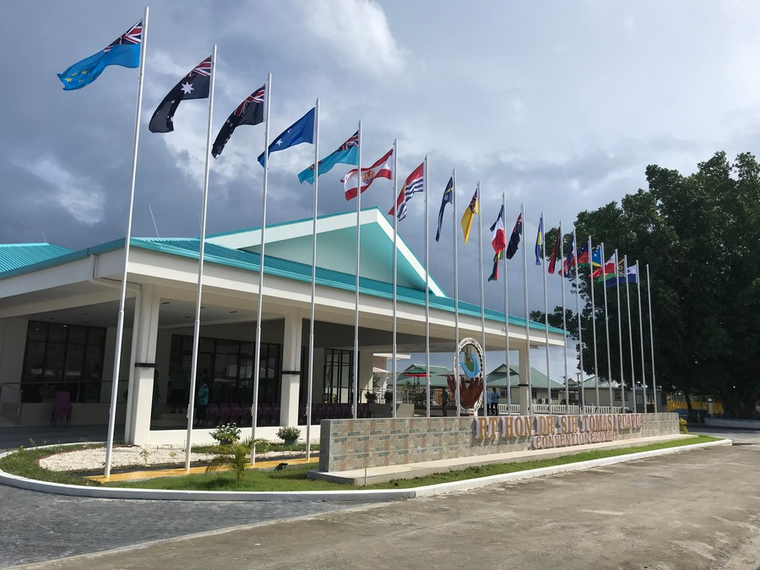

Registration
The meeting will be face-to-face and registration will start at 8 am on Day 1 of the Clean Pacific Roundtable Meeting

Accommodation
Please be informed that accommodation has been block-booked by the Government of Tuvalu for delegates. If you need accommodation for the CPRT, please contact Ms. Susana Telakau at susanat@sprep.org and Davina Tiitii at davinat@sprep.org for a reservation.

Transit Visas
You should now have completed (and hopefully received) your transit Visa through Australia, New Zealand, or any other country depending on your flights. Please note that it is your responsibility to obtain the transit visa required for traveling to Tuvalu.

Entry Visa to Tuvalu
Please note that you do not require an entry visa to Tuvalu, however, please note that you must:
- Hold a passport valid for at least six months beyond your date of country exit and with one blank visa page.
- Hold proof of onward and return flights.
- Hold all documents required for the next destination.
- Hold documents showing proof of travel purpose (e.g., business cover or support letter, conference registrations, etc.).
- Hold proof of sufficient funds relative to your intended length of stay.

Travel Insurance
Securing insurance is your responsibility. We strongly recommend all delegates secure a travel insurance policy as soon as possible. Please ensure your policy includes accident, health, etc. In the instance of this occurring, SPREP will be unable to provide financial support, so your insurance will need to be easily accessible.

Daily Subsistence Allowance (DSA)
The DSA is calculated using the standard SPREP DSA per day. DSA will be calculated on the following basis:
- DSA will be paid at the full rate (DSA to cover accommodation, meals, and incidentals).
DSA will be provided in cash in Funafuti, Tuvalu. Kindly note that Tuvalu uses Australian (AUD) currency.

